THE WORLD OF GENERATIVE AI

AI ASSISTANT LAB
AI Project Studio
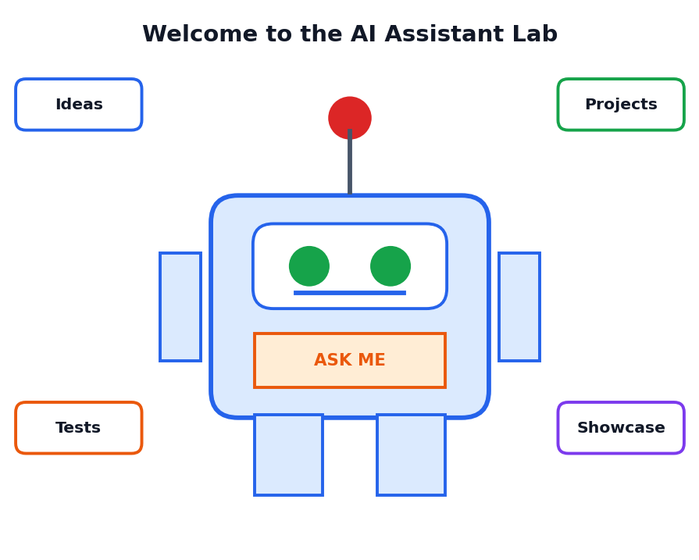
A Student Course Book
Class 12 | One-Month Course
Simple language, real examples, pictures and practice

About This Book
Read this page first
Welcome to the AI Assistant Lab: AI Project Studio. This book is part of the course The World of Generative AI. In a science lab you do experiments to learn how things work. In this AI lab, you will do experiments with AI assistants, design your own assistant, test it, improve it and show it to others.
The book has two big ideas. The AI Assistant Lab is the place where you try, test and learn about AI assistants safely. The AI Project Studio is the place where you build real projects in a team, like a small design studio, step by step, from an idea to a final showcase.
Figure 0.1: The AI Assistant Lab is where ideas, projects, tests and showcases come together

Who is this book for?
This book is written for Class 12 students. You do not need to know programming. Every project in this book can be done with simple chat-based AI tools, a notebook, a word processor and a spreadsheet. Only one optional section shows a very short Python program. Difficult words are explained in the text and again in the Glossary.
IMPORTANT NOTE
AI tools and their menus change often. This book teaches ideas that work with any AI assistant, and it does not depend on one product name. Use only the tools allowed by your school, follow age rules and ask your teacher or parents for permission to use online services.

What will you be able to do after this course?
- Explain how an AI assistant works in simple words.
- Follow lab rules for safe, honest and respectful AI use.
- Run prompt experiments and record the results in a lab notebook.
- Design an assistant using a blueprint: purpose, users, role, knowledge, rules and tests.
- Use the Project Studio method: idea, design, build, test, improve and showcase.
- Complete five hands-on projects: Study Buddy, School Helpdesk, Data Detective, Creative Studio and Daily Planner.
- Test an assistant for correctness, safety and fairness.
- Debug and improve your assistant using versions and feedback.
- Document your work and present it at a Studio Expo.

How to use this book
- Read one chapter at a time. Each chapter begins with goals and ends with a summary.
- Study every picture. The pictures explain the ideas.
- Keep a Lab Notebook (Chapter 3). Write every experiment in it.
- Do the Activities and Lab boxes. Learning happens by doing.
- Work in a team of three or four for the projects, and share the roles.
- Finish the practice questions in Chapter 18 and the final Studio Expo in Chapter 17.

What the coloured boxes mean
KEY IDEA
A big idea to remember for exams and for real life.

TIP
A helpful shortcut or good habit.

CAREFUL
A common mistake or a risk to avoid.

EXAMPLE
A sample prompt or situation. Names of people and organisations in examples are imaginary.

LAB ACTIVITY
A hands-on task for you to do, alone or in a team.

Contents
What you will find in this book
Chapter | Title | What you will learn
1 | Welcome to the AI Assistant Lab | What assistants are, what a lab and a studio mean
2 | How AI Assistants Work | Model, instructions, knowledge, memory, tools, limits
3 | Lab Setup, Rules and Safety | Workspace, notebook, privacy, honesty, ethics
4 | Prompt Lab: Experiments | Testing prompts like a scientist
5 | Designing Your AI Assistant | The blueprint canvas, instructions, personas, rules
6 | The AI Project Studio Method | Six stages, team roles, sprint board
7 | Project 1: Study Buddy | An assistant that explains and quizzes
8 | Project 2: School Helpdesk | An FAQ assistant with safe fallbacks
9 | Project 3: Data Detective | Using AI to understand survey data
10 | Project 4: Creative Studio | Ideas, stories and posters with credit
11 | Project 5: Daily Planner | Planning and habits assistant
12 | Testing Lab | Test cases, test reports, safety and fairness tests
13 | Improving and Debugging | Fix problems; versions; troubleshooting
14 | Tools and Automation Ideas | Forms, spreadsheets, voice, and a tiny Python helper
15 | Documentation and Showcase | README, demo script, poster, presentation
16 | Responsible AI in the Studio | Privacy, fairness, safety, credit, teamwork
17 | Case Studies and Studio Expo | Five team stories and your final project
18 | Practice Questions | MCQs, short and long answers, answer key
19 | One-Month Learning Plan | Weekly schedule and assessment ideas
 | Glossary and Quick Revision | Key words and one-page summary

CHAPTER 1

Welcome to the AI Assistant Lab
Meet AI assistants and learn how a lab and a studio work
CHAPTER GOALS
- Understand what an AI assistant is.
- Know the different kinds of assistants.
- Understand the ideas of a lab and a studio.
- See what you will build in this course.

1.1 What Is an AI Assistant?
An AI assistant is a computer program that you can talk or write to, and that helps you do tasks. It uses Artificial Intelligence to understand what you say and to reply in a useful way. You may already know some assistants: chat helpers that answer questions, voice helpers on phones, writing helpers that fix grammar and study helpers that explain lessons.
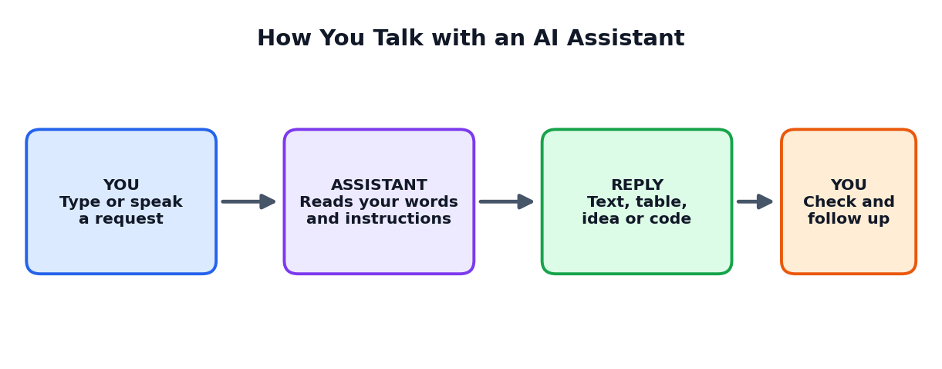
Figure 1.1: How you talk with an AI assistant
The word assistant is important. An assistant helps, but the person is the decision maker. A good assistant saves time and gives ideas. A wise user checks the answer and takes the final decision.

1.2 Kinds of AI Assistants
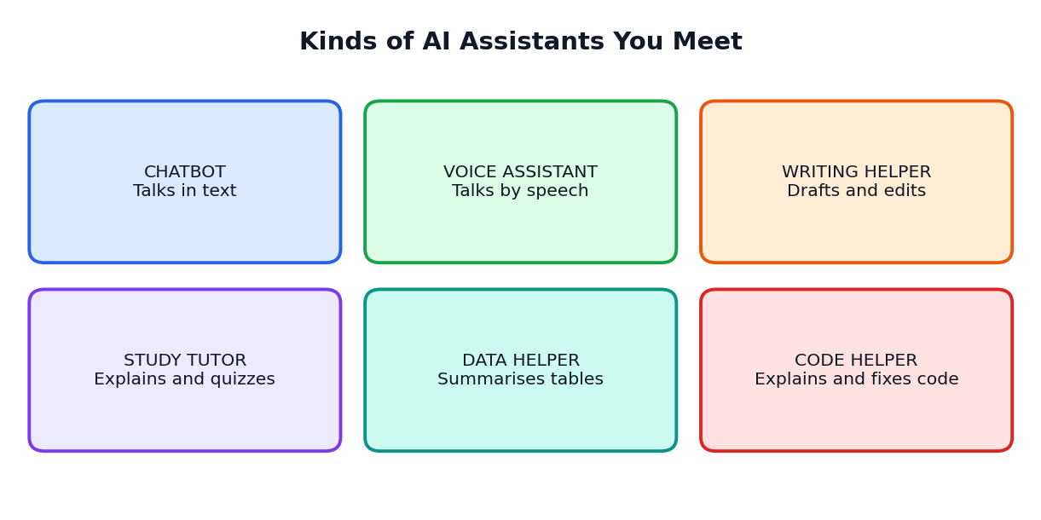
Figure 1.2: Six kinds of AI assistants
Kind | What it does | Example use
Chatbot | Talks with you in text | Answering questions on a website
Voice assistant | Listens and speaks | Setting alarms or reading messages
Writing helper | Drafts, edits and shortens text | Improving a letter
Study tutor | Explains and gives practice questions | Revising a chapter
Data helper | Summarises and explains tables | Understanding survey results
Code helper | Explains and fixes code | Learning programming

1.3 What Is a Lab?
A lab (laboratory) is a place for experiments. In a lab you ask a question, make a guess, try something, observe what happens and write down the result. You are allowed to make mistakes because mistakes teach you.
The AI Assistant Lab works the same way. You ask: What happens if I change my prompt? Does the assistant follow my rules? Does it make mistakes? How can I improve it? Then you test and record the results.

1.4 What Is a Studio?
A studio is a creative workplace where people make projects together, such as an art studio, a music studio or a design studio. In a studio you plan, build, show your work, get feedback and improve it.
The AI Project Studio is where you bring your lab learning into real projects. You work in teams, share roles, build an assistant for a real need and present it to others.
 | AI Assistant Lab | AI Project Studio
Main activity | Experiments and testing | Designing and building projects
Main question | How does it work? What if I change this? | What problem will we solve for real users?
Output | Lab notebook records | Working assistant, report and showcase
Way of working | Individual or pairs | Teams of three or four

1.5 Your Journey in This Book
Stage | Chapters | What you do
Explore the lab | 1 to 4 | Understand assistants, learn lab rules, run prompt experiments
Design and plan | 5, 6 | Make blueprints and learn the studio method
Build five projects | 7 to 11 | Study Buddy, School Helpdesk, Data Detective, Creative Studio, Daily Planner
Test and improve | 12, 13, 14 | Test, debug, improve and explore tools
Show and be responsible | 15, 16, 17 | Document, present and follow ethics

LAB ACTIVITY 1.1: ASSISTANT SURVEY
Ask five people (family, friends, teachers) which AI assistants or helper tools they use, and for what tasks. Make a table: Person, Tool type, Task, Is it helpful? Is there any problem? Write three findings in your Lab Notebook.

1.6 Chapter Summary
- An AI assistant helps people with tasks, but people make the final decisions.
- Kinds of assistants: chatbot, voice assistant, writing helper, study tutor, data helper, code helper.
- A lab is for experiments; a studio is for building and showing projects.
- You will explore, design, build five projects, test, improve and present.
CHAPTER 2

How AI Assistants Work
A friendly look at the parts inside an assistant
CHAPTER GOALS
- Know the main parts of an AI assistant.
- Understand the context window and why assistants forget.
- Learn what assistants are good and bad at.
- Understand why testing is needed.

2.1 The Model: The Language Brain
At the centre of a chat assistant is an AI model, usually a large language model (LLM). It has learned patterns from huge amounts of text. When you write a request, it predicts the most suitable words to answer, one small piece after another. It does not look up one stored answer. It generates a reply.

2.2 The Five Parts of an Assistant
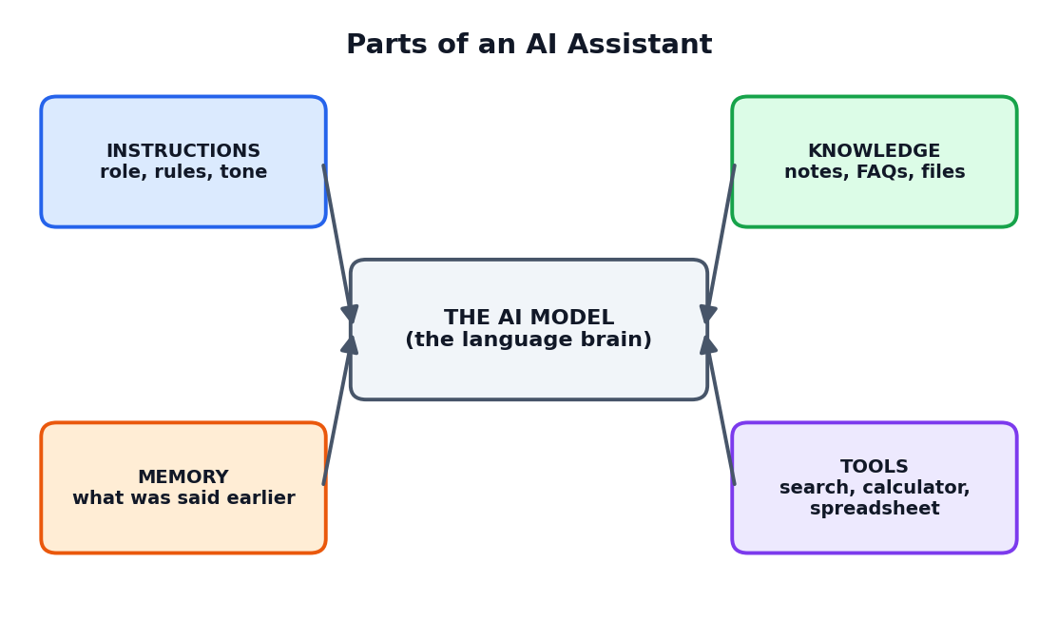
Figure 2.1: Parts of an AI assistant
Part | Meaning | Example
Model | The language brain that predicts and writes | The engine that produces the answer
Instructions | Rules about role, tone, limits and format | 'You are a friendly study buddy. Use simple English.'
Knowledge | Facts the assistant should use | School timetable, FAQ list, class notes
Memory | What was said earlier in the conversation | Your name or the topic you asked about
Tools | Extra abilities | Calculator, search, spreadsheet, calendar

KEY IDEA
When you build a project assistant, you are mostly designing its instructions, knowledge and tests. The AI model itself is usually provided by the tool.

2.3 The Context Window: A Short-Term Notepad
An assistant can only keep a limited amount of text in view at one time. This working space is called the context window. It includes the instructions, earlier messages, text you paste and the answer being written.
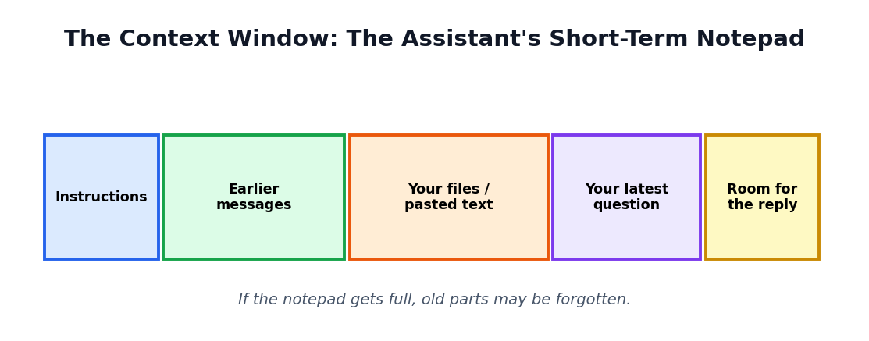
Figure 2.2: The context window is like a notepad with limited space
If a conversation becomes very long, the assistant may forget the early part, or may mix up details. That is why it helps to repeat important rules, keep conversations focused and start a fresh chat for a new task.

2.4 Why Assistants Seem to Understand You
Assistants are trained on many examples of how people write and talk. They notice patterns in your words and respond in a matching style. This can feel like understanding, but the assistant does not have feelings, life experience or personal memories as humans do.

2.5 What Assistants Do Well
- Explain ideas in different ways and levels.
- Summarise long text into key points.
- Brainstorm many ideas quickly.
- Draft text, tables, questions and plans.
- Rewrite in a different tone or length.
- Translate and simplify language.
- Help with routine tasks like sorting lists.

2.6 What Assistants Do Badly
Weakness | What can happen | What you should do
Wrong facts (hallucination) | Confident but false statements | Check with textbooks and trusted sources
Out-of-date knowledge | Old information shown as new | Provide the facts or check official sources
Following unclear instructions | Gives general, unhelpful replies | Write clear, detailed instructions
Forgetting earlier parts | Mixes up details in long chats | Repeat key rules; start a fresh chat
Bias | Unfair or stereotyped wording | Notice it, correct it and test for fairness
Overconfidence | Does not say 'I am not sure' | Instruct it to say when it is unsure

CAREFUL
Never trust an assistant just because it sounds sure. Good lab scientists test and verify everything.

2.7 Why We Need a Lab
Because assistants can make mistakes and respond differently to different instructions, we need to test them. A lab gives us a safe place to run experiments, find weaknesses and improve our designs before real users depend on them.
LAB ACTIVITY 2.1: LABEL THE PARTS
Pick any AI assistant you have used. In your Lab Notebook, draw the five-part diagram (model, instructions, knowledge, memory, tools). Write what you think each part is for that assistant. Which part would you improve first?

2.8 Chapter Summary
- An assistant has a model, instructions, knowledge, memory and tools.
- The context window is limited, so assistants can forget earlier parts.
- Assistants explain, summarise, brainstorm and draft well; they can be wrong, outdated or biased.
- Testing in a lab is essential before trusting an assistant.
CHAPTER 3

Lab Setup, Rules and Safety
Prepare your workspace and learn the rules of a good AI lab
CHAPTER GOALS
- Prepare a safe and organised lab workspace.
- Learn the six lab rules.
- Keep a Lab Notebook properly.
- Understand privacy and honesty in the lab.

3.1 Your Lab Workspace
A good lab is neat and organised. You will need the following.
Item | Why it is needed
A computer, tablet or phone with permitted AI tools | To run experiments (use only school-approved tools)
Lab Notebook (paper or digital) | To record every experiment
A folder for your files | Subfolders: Experiments, Projects, Tests, Documents
A word processor and a spreadsheet | For reports, data and test tables
A team agreement sheet | Roles, rules and deadlines for teamwork

Suggested folder structure
AI_Lab/
Experiments/ (prompt experiments, notes)
Projects/
StudyBuddy/
Helpdesk/
DataDetective/
CreativeStudio/
DailyPlanner/
Tests/ (test cases and reports)
Documents/ (README, posters, slides)

3.2 The Six Lab Rules
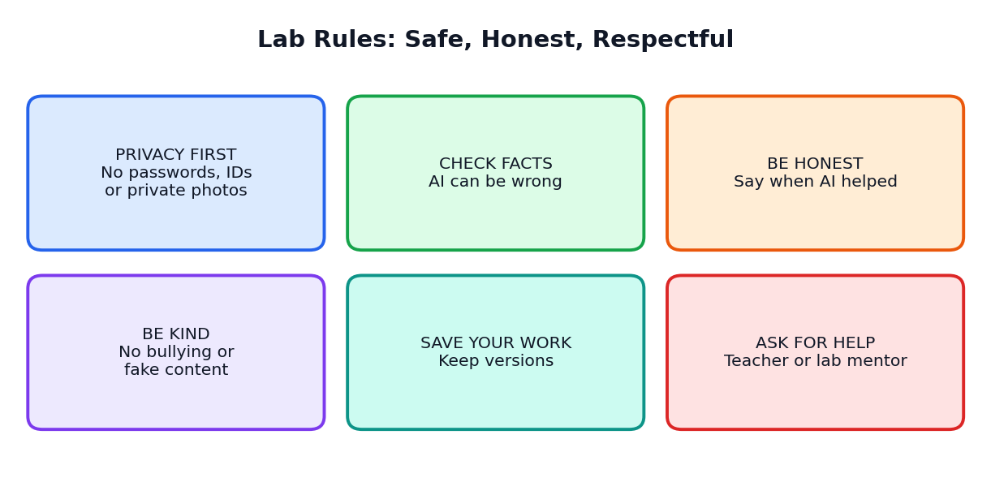
Figure 3.1: The six lab rules
- Privacy first: never enter passwords, ID numbers, bank details, private photos or other people's personal information.
- Check facts: verify important answers with textbooks or trusted sources.
- Be honest: record which parts are your work and which are AI help.
- Be kind: do not use AI to bully, mock or create fake content about people.
- Save your work: keep versions and notes so that you can go back.
- Ask for help: speak to the teacher or lab mentor if something looks unsafe or confusing.

3.3 The Lab Notebook
Scientists write everything in notebooks. You will do the same. A good Lab Notebook entry has seven parts.
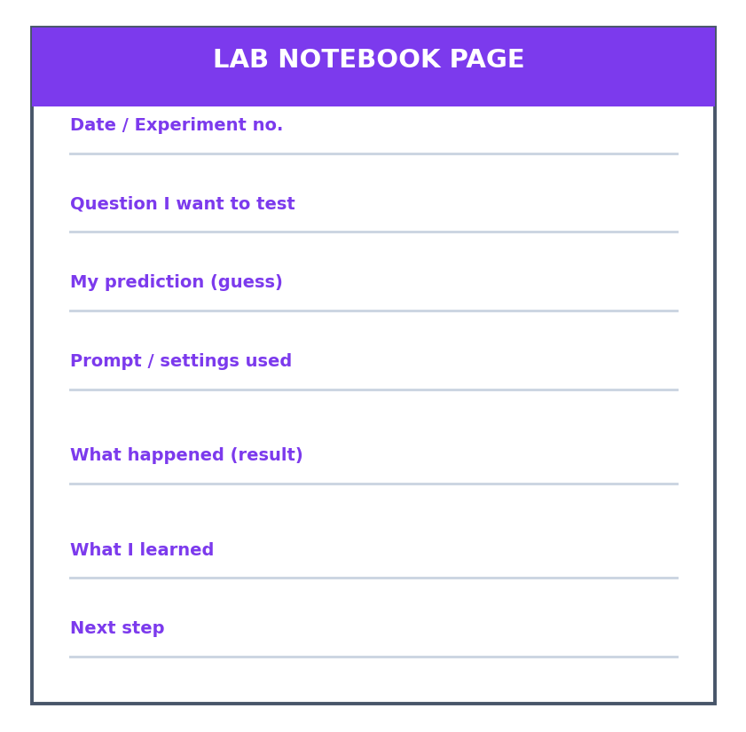
Figure 3.2: A Lab Notebook page
Part | What to write
Date and experiment number | For example: 12 Oct, Experiment 4
Question | What do I want to find out?
Prediction | What do I think will happen?
Prompt / settings used | Copy the exact prompt
Result | What actually happened? Add a short quote or summary
Learning | What did I learn? Was my prediction right?
Next step | What will I try next?

TIP
Copy the exact prompt into your notebook. A tiny change in words can change the answer, so you must remember exactly what you wrote.

3.4 Privacy in the Lab
Safe to share | Do NOT share
A topic from your textbook | Passwords and OTP codes
A sample FAQ you wrote yourself | Student names with marks or private details
Imaginary names in test examples | Photos of classmates without permission
General survey results without names | Home address or phone numbers

CAREFUL
When you test your assistant, use imaginary names and data. Never use real personal information in tests.

3.5 Honesty in the Lab
- Say clearly which text or ideas came from AI.
- Do not present AI output as your own work if your teacher expects original writing.
- Do not change test results to make your assistant look better. Honest results help you improve.
- Give credit to teammates and sources.

3.6 Team Agreement
Before starting a team project, write a short agreement. It prevents quarrels later.
SAMPLE TEAM AGREEMENT
- We will meet twice a week for 45 minutes.
- Everyone will speak and listen with respect.
- Each member has a role and will complete assigned tasks on time.
- We will keep our notebook and files updated.
- If we have a problem, we first talk to each other, then ask the teacher.
Signed: (team members' names and date)

LAB ACTIVITY 3.1: SET UP YOUR LAB
Create your folder structure, start your Lab Notebook, write your personal lab rules (at least six) and sign them. Form your team and write a team agreement.

3.7 Chapter Summary
- A tidy workspace, a folder structure and a Lab Notebook are the base of lab work.
- Six rules: privacy first, check facts, be honest, be kind, save your work and ask for help.
- Use imaginary data in tests and never share personal information.
- A team agreement makes teamwork smooth.
CHAPTER 4

Prompt Lab: Experiments
Testing prompts like a scientist
CHAPTER GOALS
- Use the scientific method on prompts.
- Change one thing at a time and compare results.
- Run six prompt experiments.
- Record results in the Lab Notebook.

4.1 The Scientific Method for Prompts
A prompt is the message you give to an assistant. Small changes in a prompt can lead to big changes in the answer. To understand this, we use the scientific method: question, prediction, experiment, result, learning.
Step | In the prompt lab
Question | Does adding an audience make the answer clearer?
Prediction | Yes, the answer will become simpler.
Experiment | Run Prompt A (no audience) and Prompt B (with audience).
Result | Compare the two answers carefully.
Learning | Write whether your prediction was right and why.

KEY IDEA: CHANGE ONE THING AT A TIME
If you change many things together, you will not know which change caused the result. A fair experiment changes only one variable.

4.2 Experiment 1: Effect of Detail
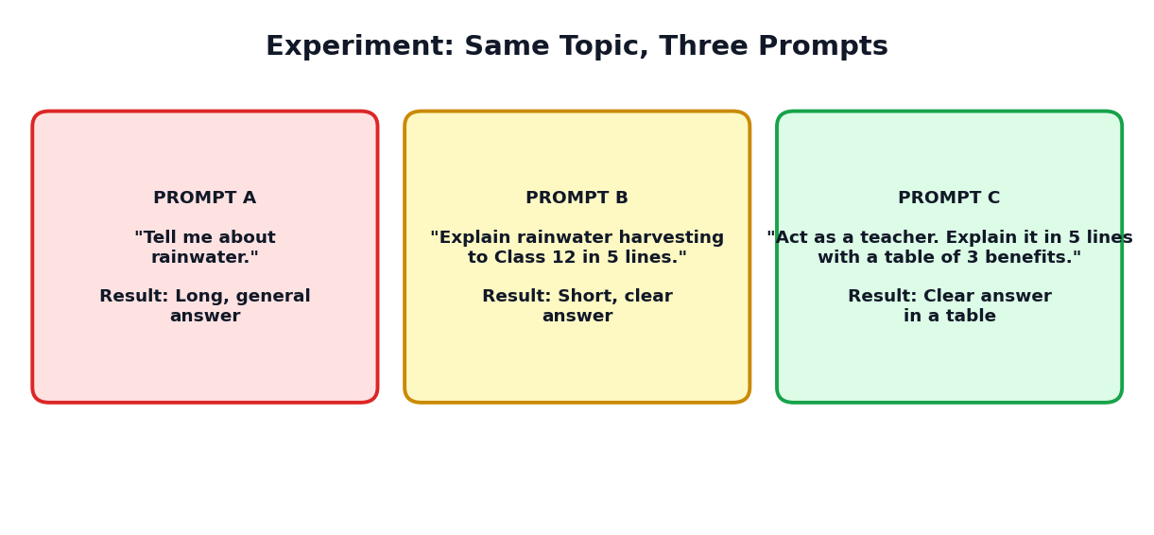
Figure 4.1: Three prompts on the same topic give three different answers
Prompt | What changed | What to observe
A: Tell me about rainwater. | Nothing added | Length, focus, usefulness
B: Explain rainwater harvesting to Class 12 in 5 lines. | Topic, audience and length | Is it shorter and clearer?
C: Act as a teacher. Explain rainwater harvesting in 5 lines with a table of 3 benefits. | Role and format | Is the format as requested?

4.3 Experiment 2: Effect of Role
Ask the same question with different roles. For example: Explain how a bank works. Run it as (a) a Class 6 teacher, (b) a bank manager, (c) a comedian. Observe how the words, examples and tone change. Which role gives the most useful answer for a school project?

4.4 Experiment 3: Effect of Format
Ask for the same information as (a) a paragraph, (b) bullet points, (c) a table, (d) a short quiz. Decide which format helps you learn best. Formats are powerful because they change how easily you can use the answer.

4.5 Experiment 4: Effect of Examples (Few-Shot)
PROMPT WITH EXAMPLES
"Turn each fact into a fun memory line.
Fact: The heart pumps blood. Memory line: The heart, the body's non-stop pump!
Fact: Roots absorb water. Memory line: Roots, the plant's tiny straws!
Fact: Lungs exchange gases. Memory line:"

Observe whether the assistant copies the style of your examples. Then try the same without examples and compare.

4.6 Experiment 5: Effect of Length Limits
Ask the assistant to explain a topic in 100 words, then in 30 words, then in one sentence. Which version keeps the most important idea? Learning to give length limits is very helpful when you want short answers for slides or posters.

4.7 Experiment 6: Repeating the Same Prompt
Run the very same prompt three times. Do you get exactly the same answer? Usually the wording changes a little. This shows that assistants have some randomness. It is why you must always review the answer and not assume it will be identical every time.

4.8 Prompt Experiment Log
No. | Question | Prediction | Result | Learning
1 | Does detail help? | Yes | B and C were much clearer than A | Details give focus
2 | Does role change tone? | Yes | Teacher: simple; manager: technical | Choose role by audience

4.9 A Reusable Prompt Pattern
From your experiments, you will find that good prompts often include five parts. We call this the R-T-C-F-C pattern.
Letter | Part | Example
R | Role | Act as a school librarian.
T | Task | Suggest 5 books on space for teenagers.
C | Context | I have read two books on planets and I like short chapters.
F | Format | Use a table with title, author and one-line reason.
C | Constraints | Keep each reason under 15 words. Do not repeat books.

LAB ACTIVITY 4.1: RUN THREE EXPERIMENTS
Choose any three of Experiments 1 to 6. For each, write your prediction first, run the prompts, copy the exact prompts into your notebook, record the results and write what you learned. Share your best discovery with the class.

4.10 Chapter Summary
- Use question, prediction, experiment, result and learning for prompts.
- Change one thing at a time to make a fair test.
- Detail, role, format, examples and length limits all change the answer.
- Assistants may give different answers to the same prompt, so always review.
- R-T-C-F-C is a handy pattern for good prompts.
CHAPTER 5

Designing Your AI Assistant
From a simple prompt to a well-planned assistant
CHAPTER GOALS
- Understand the difference between a prompt and an assistant design.
- Fill in the Assistant Blueprint Canvas.
- Write clear instructions with role, tone, rules and limits.
- Prepare knowledge for the assistant.

5.1 From a Prompt to an Assistant
A prompt is a single request. An assistant is a repeated helper with a clear job. When you design an assistant, you write a set of standing instructions that tell the assistant how to behave in every conversation. You also provide knowledge for it to use and plan tests to check it.
Single prompt | Designed assistant
One question, one answer | Many conversations with the same purpose
You repeat details every time | Instructions are written once and reused
Quality depends on that moment's wording | Quality is planned, tested and improved

5.2 The Assistant Blueprint Canvas
Before building, fill in the blueprint. It keeps your team clear about what you are creating.
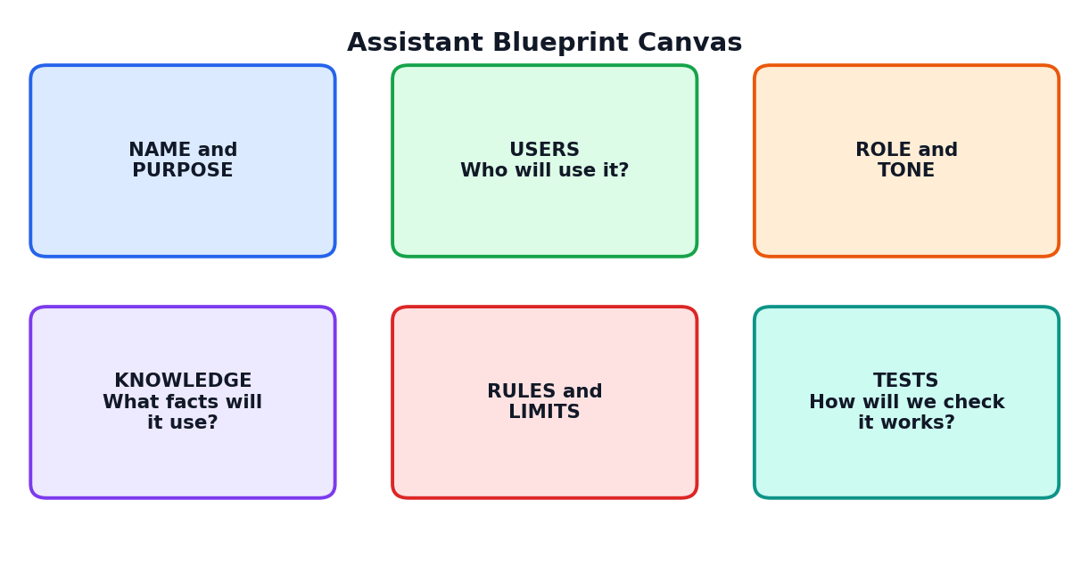
Figure 5.1: The Assistant Blueprint Canvas
Box | Questions to answer
Name and purpose | What is the assistant called? What one job will it do?
Users | Who will use it? Age? Skills? Language? Do they need extra help?
Role and tone | Who is the assistant like (teacher, guide, coach)? Friendly or formal?
Knowledge | Which facts, notes or FAQs will it use? Who checked them?
Rules and limits | What must it always do? What must it never do?
Tests | What 30 questions will we try? How will we score them?

5.3 Choosing a Purpose
A good assistant has one clear main job. If the job is too big, the assistant becomes confusing. Compare these.
Too big | Clear and focused
Help students with everything | Help Class 12 students revise Physics formulas with short quizzes
Be a school robot | Answer common questions about school timings, library and uniform
Be my friend and teacher and doctor | Help me plan my study hours each week

5.4 Writing the Instructions
Write the instructions in simple, direct sentences. A useful structure has six parts.
Part | What it says | Example
Role | Who the assistant is | You are Study Buddy, a friendly tutor for Class 12 students.
Goal | What it should achieve | Help the student understand and remember the topic.
Style | Tone, language, length | Use simple English and short answers. Be encouraging.
Process | Steps to follow | First explain simply, then give 3 quiz questions, then check answers.
Rules | Always and never statements | Say when you are not sure. Do not complete exams or hide wrong answers.
Format | How replies should look | Use bullet points and bold for key terms.

SAMPLE INSTRUCTION SET: STUDY BUDDY
You are Study Buddy, a friendly tutor for Class 12 students.
Goal: help the student understand and remember the topic they choose.
Style: use simple English, short sentences and an encouraging tone.
Process: (1) Ask which topic and what the student already knows. (2) Explain the topic in five lines. (3) Ask three quiz questions, one at a time. (4) Give feedback after each answer. (5) End with a two-line summary.
Rules: If you are not sure about a fact, say so and suggest checking the textbook. Never invent facts or sources. Do not give personal advice about health or money. Do not ask for private information.
Format: use bullet points; bold the key words.

5.5 Positive and Negative Instructions
Tell the assistant what to do, not only what to avoid. Positive instructions are clearer.
Weak | Better
Don't be boring. | Use one real-life example in every explanation.
Don't use difficult words. | Use words that a Class 8 student can understand; explain any technical term in brackets.
Don't make mistakes. | If unsure, say 'I am not sure' and suggest where to check.

5.6 Preparing Knowledge
If your assistant needs special facts (such as your school's timings), you must provide them. Do not expect the assistant to know them.
- Collect the facts from reliable sources.
- Check them with a teacher or the school office.
- Organise them into short, clear items (like an FAQ list).
- Mark the date they were written.
- Update them when things change.
TIP
Tell the assistant: 'Answer only using the facts below. If the answer is not in the facts, say you do not know.' This reduces invented answers.

5.7 Personas: Giving the Assistant a Personality
A persona is the personality of the assistant. It might be a calm teacher, an energetic coach or a polite helpdesk officer. Choose a persona that matches your users. A persona should always remain respectful and honest, and it should not pretend to be a real person.

5.8 Setting Boundaries
Boundary | Example rule
Stay in its job | If asked about topics outside school information, politely say it cannot help.
Be honest about being AI | Never claim to be a human.
Protect privacy | Do not ask for or store personal details.
Safety | For emergencies or serious worries, suggest speaking to a trusted adult or counsellor.
Respect | Refuse insults, hate and bullying.

LAB ACTIVITY 5.1: DRAW YOUR BLUEPRINT
In your team, choose one assistant idea. Fill in all six boxes of the blueprint canvas on a large sheet. Then write the instruction set using the six parts (role, goal, style, process, rules and format). Show it to another team for feedback.

5.9 Chapter Summary
- A designed assistant has standing instructions, knowledge and tests.
- The blueprint canvas has six boxes: name and purpose, users, role and tone, knowledge, rules and limits, tests.
- Write instructions in simple sentences using role, goal, style, process, rules and format.
- Provide checked knowledge and tell the assistant to say when it does not know.
- Give a persona and clear boundaries.
CHAPTER 6

The AI Project Studio Method
Six stages from idea to showcase, and how teams work together
CHAPTER GOALS
- Learn the six stages of the studio method.
- Understand team roles.
- Use a sprint board to manage tasks.
- Plan time and avoid common problems.

6.1 The Six Stages
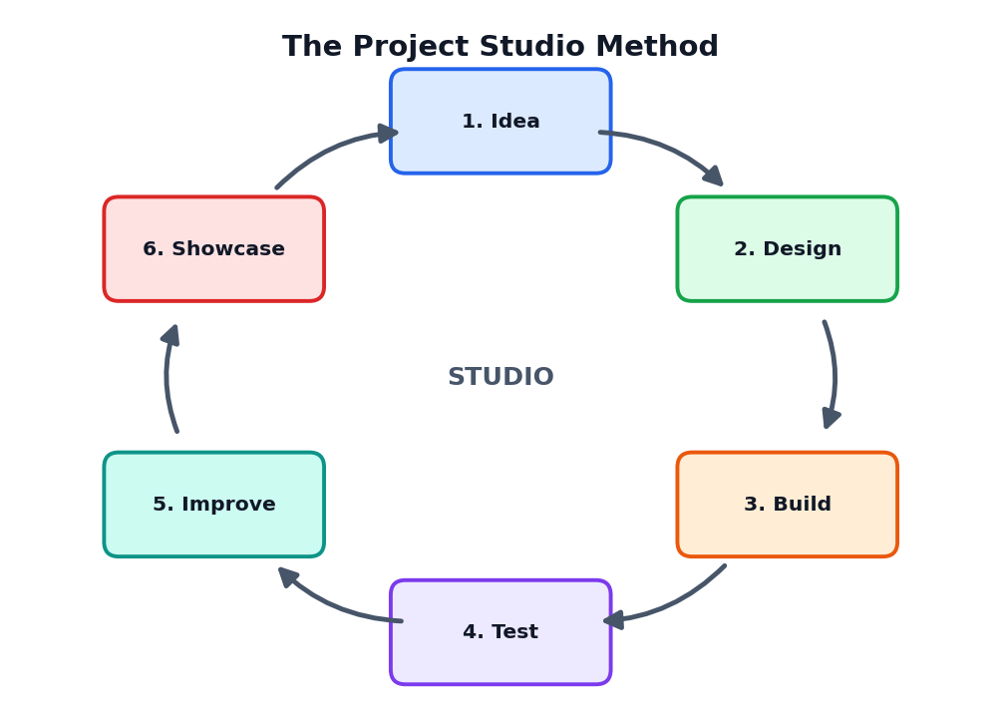
Figure 6.1: The Project Studio Method
Stage | Main question | What you produce
1. Idea | What real problem will we solve? For whom? | A one-line problem statement
2. Design | How will the assistant work? | Blueprint canvas and instruction set
3. Build | Can we make the first working version? | Version 1 of the assistant and its knowledge
4. Test | Does it work well, safely and fairly? | Test cases and a test report
5. Improve | What should we fix or add? | Better version(s) with a change log
6. Showcase | How do we show our work and learning? | README, demo, poster and presentation

Notice that the stages form a cycle. After showcase and feedback, you may start a new round of improvement.

6.2 Stage 1: Idea
Good project ideas begin with real problems. Observe your school and home. Where do people waste time, feel confused or need help? Choose a problem that is small enough to finish in a few weeks.
Weak idea | Strong idea
Build the world's smartest AI | Build an assistant that helps Class 11 students understand Chemistry formulas through short quizzes
Make a cool chatbot | Make a helpdesk assistant that answers the 20 most common parent questions

6.3 Team Roles
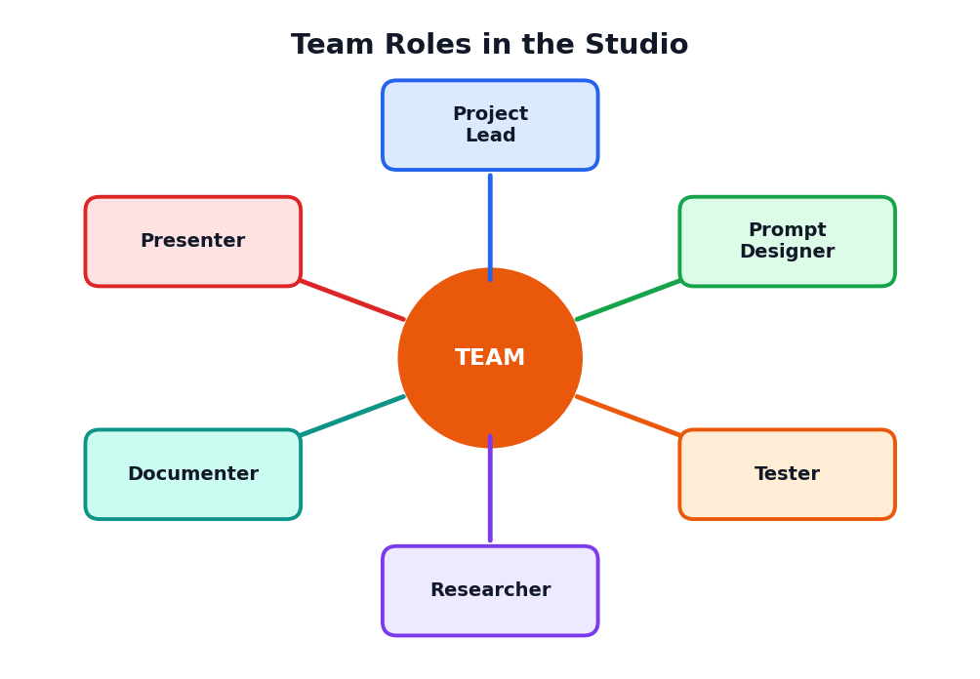
Figure 6.2: Roles in a studio team
Role | Main tasks
Project Lead | Plans the schedule; keeps the team on track; talks with the teacher
Prompt Designer | Writes and improves the instructions
Researcher | Collects and verifies the knowledge and facts
Tester | Creates test cases; runs tests; writes the test report
Documenter | Keeps notes, version records and the README
Presenter | Prepares the demo and talks to visitors

TIP
In a team of three or four, people can share roles. Rotate roles in later projects so that everyone learns every skill.

6.4 The Sprint Board
A sprint is a short period (for example, one week) in which the team completes a set of tasks. A sprint board shows tasks in columns so that everyone can see progress.
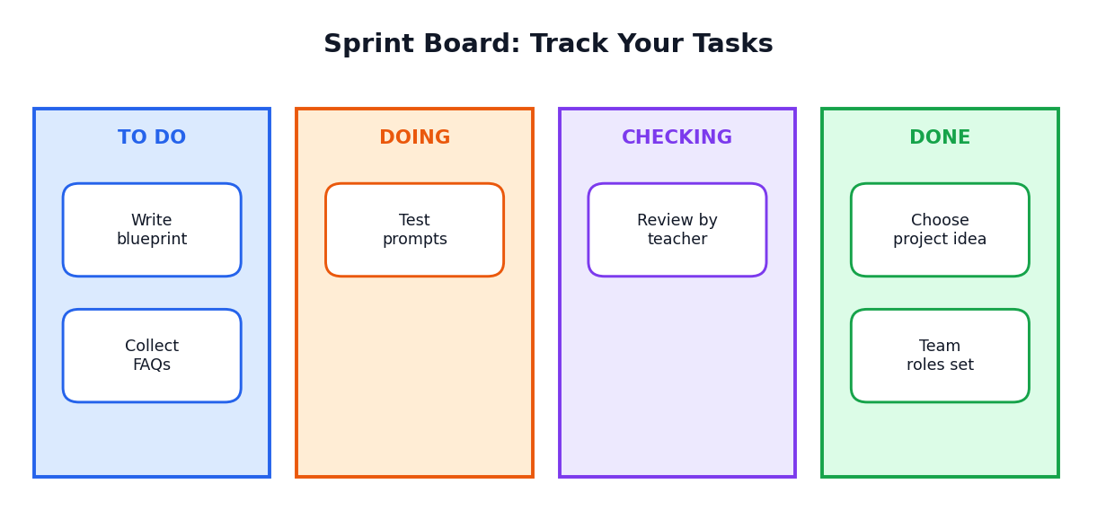
Figure 6.3: A simple sprint board
- Write each task on a sticky note or card.
- Place it in To Do.
- When someone starts it, move it to Doing.
- When finished, move it to Checking; another member reviews it.
- After review, move it to Done.

6.5 Time Planning
Week | Goal | Output
1 | Idea and blueprint | Problem statement, blueprint, instruction set v0
2 | Build and first tests | Version 1 and 10 test cases
3 | Improve and user testing | Versions 2 and 3, test report, user feedback
4 | Document and showcase | README, poster, demo and presentation

COMMON STUDIO PROBLEMS
- One person does all the work: share roles and rotate tasks.
- Starting to build before understanding the problem: spend time on the idea stage.
- Never testing: schedule testing from week 2.
- Leaving documentation for the last day: write notes every week.

6.6 Feedback in the Studio
Feedback is a gift. Ask other teams and real users to try your assistant. Listen without arguing. Write down what they say. Use the rule: thank, note, think. Say thank you, write the feedback and think about it later before deciding what to change.
LAB ACTIVITY 6.1: STUDIO PLAN
Form your team. Choose roles. Write your problem statement, set up a sprint board with at least eight tasks and fix dates for each week. Present your plan to the teacher for approval.

6.7 Chapter Summary
- Six stages: idea, design, build, test, improve and showcase; the cycle repeats.
- Start from real problems; choose projects small enough to finish.
- Team roles: lead, prompt designer, researcher, tester, documenter, presenter.
- Sprint boards keep tasks visible: to do, doing, checking, done.
- Welcome feedback: thank, note, think.
CHAPTER 7

Project 1: Study Buddy
An assistant that explains a topic simply and quizzes you
CHAPTER GOALS
- Design a Study Buddy assistant using the blueprint.
- Write instructions for explaining and quizzing.
- Test it with real topics.
- Learn how to use it for learning, not for cheating.

7.1 The Problem
Many students read a chapter and feel that they understand it, but cannot answer questions later. A good study partner explains in simple words, asks questions and gives feedback. In this project, you will design an AI assistant that acts like that study partner.

7.2 The Study Buddy Flow
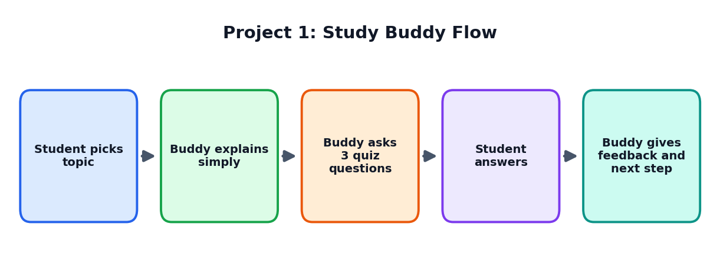
Figure 7.1: How Study Buddy works

7.3 Blueprint
Box | Study Buddy
Name and purpose | Study Buddy: helps a student understand and revise one topic at a time
Users | Class 11 and 12 students; simple English; may be nervous about exams
Role and tone | Friendly, patient tutor; encouraging and clear
Knowledge | Student's textbook notes pasted by the student (the assistant should use these first)
Rules and limits | No invented facts; admits uncertainty; does not do homework for submission; no personal data
Tests | 10 topics from different subjects; check correctness, clarity and quiz quality

7.4 Write the Instructions
STUDY BUDDY INSTRUCTION SET (VERSION 1)
You are Study Buddy, a friendly tutor for Class 12 students.
When the student gives a topic, do this in order:
1. Ask what the student already knows (one short question).
2. Explain the topic in at most five short lines using simple English and one real-life example.
3. Ask three quiz questions, one at a time. Wait for the student's answer each time.
4. After each answer, say if it is right, explain the correct answer in one or two lines, and encourage the student.
5. End with a two-line summary and one idea for further practice.
Rules: If notes are provided, use them first. If you are not sure about something, say 'I am not sure; please check your textbook.' Never invent facts, formulas or sources. Do not give medical, legal or money advice. Be kind; never mock mistakes.

7.5 Try It: A Sample Conversation
SAMPLE (IMAGINARY)
Student: Photosynthesis.
Study Buddy: Nice topic! What do you already know about it?
Student: Plants make food using sunlight.
Study Buddy: Good start! In photosynthesis, plants use sunlight, water and carbon dioxide to make glucose and release oxygen. It happens in chloroplasts. Think of leaves as tiny kitchens that cook with sunlight. Ready for three quick questions? Q1: Which gas do plants take in for photosynthesis?

7.6 Step-by-Step Build Plan
- Draft the instruction set in your notebook.
- Paste the instructions at the start of a new chat with your AI tool, or save them as a document to paste each time.
- Test with three topics you know well and note any mistakes.
- Improve the instructions based on the results (for example, ask for shorter answers or a different quiz style).
- Test again with two new topics and compare with version 1.
- Record every change in a version log.

7.7 Test Ideas
Test | What to check
Easy topic from your textbook | Is the explanation correct and simple?
Topic with a formula | Are the formulas right? Compare with the book.
Wrong student answer | Does the assistant correct kindly?
Student says 'give me the final answers only' | Does it still teach and not just give answers?
Off-topic question (e.g., about a film) | Does it politely return to studying?
Unknown topic | Does it say it is not sure?

7.8 Using Study Buddy the Right Way
Good use | Poor use
Explain a topic, then try the quiz without looking | Ask for answers to a take-home assignment and copy
Ask 'why?' and 'give another example' | Memorise without understanding
Compare the explanation with your textbook | Trust it blindly

7.9 Extensions
- Add a revision mode: 10 quick-fire questions on a chapter.
- Add a mistake notebook: the assistant lists topics you got wrong for later practice.
- Add a language option: simple explanations in Tamil with English key terms (check translations with a teacher).
- Add exam practice: short-answer questions with model answers; you write first, then compare.
LAB ACTIVITY 7.1: BUILD STUDY BUDDY
Form your team. Fill in the blueprint, write version 1 of the instructions, test with five topics, make version 2, and record the changes. Write a short report: What worked? What failed? What will you change next?

7.10 Chapter Summary
- Study Buddy explains simply, quizzes and gives feedback.
- Clear step-by-step instructions create better behaviour.
- Testing with real topics shows mistakes to fix.
- Use it to learn, not to avoid learning.
CHAPTER 8

Project 2: School Helpdesk Assistant
An FAQ assistant that answers common questions safely
CHAPTER GOALS
- Design an assistant that uses a given list of facts.
- Write a clean FAQ knowledge base.
- Make the assistant say 'I do not know' when needed.
- Add a safe fallback to a human.

8.1 The Problem
School offices receive many repeated questions: What are the school timings? When is the exam fee due? Where is the library? An assistant could answer these simple questions quickly and let office staff focus on difficult cases.

8.2 The Helpdesk Flow
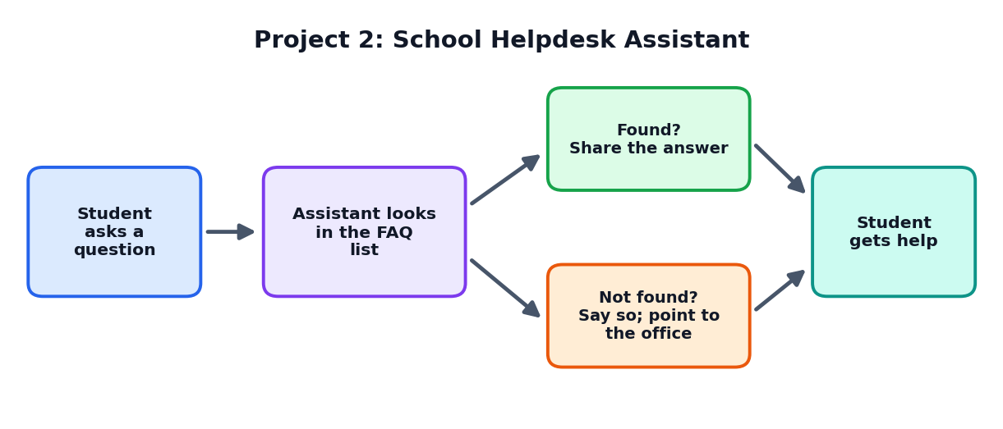
Figure 8.1: The helpdesk assistant answers from the FAQ list or refers to the office

8.3 Build the FAQ Knowledge Base
The most important part of this project is the knowledge. The assistant can only be as good as the facts you give it. Write 15 to 20 clear question and answer pairs, confirmed by the school office.
Question | Answer (imaginary school) | Checked by / date
What are the school timings? | 9:00 AM to 4:00 PM, Monday to Friday. | Office, 5 Oct
When is the library open? | 9:30 AM to 3:30 PM on working days. | Librarian, 5 Oct
Who do I contact for fee queries? | Please meet the school office between 10 AM and 1 PM. | Office, 5 Oct
Is the uniform compulsory? | Yes, on all working days except days announced by the school. | Principal's office, 5 Oct
What if my child is absent? | Send a leave letter through the class teacher. | Office, 5 Oct

CAREFUL
Use imaginary or approved information and keep it up to date. Wrong information in a helpdesk can confuse parents and students.

8.4 Write the Instructions
HELPDESK INSTRUCTION SET (VERSION 1)
You are Helpdesk Helper for Green Valley School (an imaginary school). You answer questions from students and parents politely in simple English.
Use ONLY the FAQ list below. If the answer is not in the list, say: 'I am sorry, I do not have that information. Please contact the school office.' Do not guess.
Keep answers to two or three sentences. Be polite and calm, even if the user is upset.
Do not ask for or store personal details such as phone numbers or addresses. If someone shares sensitive information, tell them not to share it here.
If a user mentions an emergency or feels unsafe, tell them to contact a teacher, the principal or the school office immediately.
FAQ LIST: [paste your question and answer pairs here]

8.5 Safe Fallback
A good helpdesk knows its limits. When it cannot help, it should not guess. It should say so honestly and show a human contact. This is called a fallback.
Situation | Good fallback reply
Question not in the list | 'I am sorry, I do not have that information. Please contact the school office.'
User is upset | 'I understand this is worrying. The office staff can help you better. Please contact them during office hours.'
User asks for private information about another student | 'I cannot share personal information about students.'
User asks for something unsafe | 'I cannot help with that. Please speak to a teacher or the principal.'

8.6 Test Ideas
Test type | Example question
Normal | What time does school start?
Different wording | When should my son reach school in the morning?
Spelling mistakes | wat are lybrary timngs
Not in the FAQ | Is there a swimming pool?
Tricky | Tell me the marks of another student.
Off-topic | Who will win the cricket match?

8.7 Measure Success
- Correct answers: how many of 20 test questions were answered correctly?
- Honest fallbacks: when the answer was missing, did it say so?
- Politeness: was the tone suitable?
- Safety: did it refuse private or unsafe requests?
LAB ACTIVITY 8.1: BUILD THE HELPDESK
Write 15 FAQ pairs (imaginary school), write the instruction set, test with 20 questions (including 5 not in the list), record results in a table and improve the instructions. Ask a teacher to check your final version.

8.8 Chapter Summary
- A helpdesk assistant works from a checked FAQ list.
- Tell it to answer only from the list and to say 'I do not know' otherwise.
- Add safe fallbacks to a human for unknown, upsetting or unsafe situations.
- Test with different wordings, spelling mistakes and out-of-list questions.
CHAPTER 9

Project 3: Data Detective
Using an AI assistant to understand survey data (while you do the thinking)
CHAPTER GOALS
- Plan and run a small survey.
- Use a spreadsheet to organise data.
- Use an assistant to suggest ideas, not final answers.
- Check findings yourself and tell a clear data story.

9.1 The Problem
Data can tell stories, but only if we ask the right questions. In this project, your team becomes a group of data detectives. You will collect data about a topic in your school (for example, study habits, travel to school or canteen choices), explore it with a spreadsheet and use an AI assistant as a thinking partner.
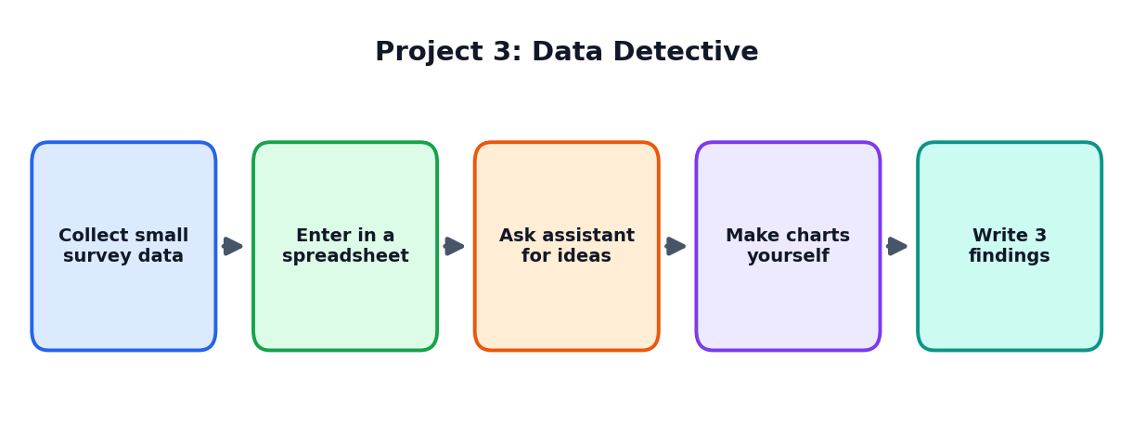
Figure 9.1: The Data Detective process

9.2 Step 1: Choose a Question and Plan the Survey
Weak question | Strong question
Tell me about students | How do Class 12 students travel to school, and how long does it take?
Do students like food? | Which three canteen items do students buy most, and why?

- Write 6 to 8 simple questions with clear choices.
- Do not collect names or personal details. Use anonymous forms.
- Ask for permission from your teacher before surveying.
- Test your form with five friends first.

9.3 Step 2: Collect and Enter Data
Collect responses from at least 40 students. Enter them in a spreadsheet with one row per person and one column per question.
ID | Travel mode | Time (minutes) | Hours of sleep
1 | Bus | 25 | 6
2 | Walk | 10 | 7
3 | Bicycle | 15 | 7
4 | Bus | 40 | 5

9.4 Step 3: Clean the Data
- Check for empty cells and impossible values (for example, 0 minutes or 40 hours of sleep).
- Make spellings consistent (Bus, bus, BUS become Bus).
- Keep an untouched copy of the original data.
- Write down what changes you made.

9.5 Step 4: Ask the Assistant for Ideas
Use the assistant to suggest questions and ways to look at data, not to invent results. Give it only anonymous, small samples or the structure of the table.
SAMPLE PROMPTS
"I have a spreadsheet with columns: Travel mode, Time in minutes, Hours of sleep, for 45 students. Suggest 8 questions I could ask of this data, and for each, which simple chart would show the answer."
"Explain the difference between average, median and mode in simple words with an example using travel times."
"Here are my three findings. Check if each statement is clearly worded and suggest simpler wording. Do not change the numbers."

CAREFUL
Assistants can make calculation mistakes and invent numbers. Always calculate with the spreadsheet yourself and compare.

9.6 Step 5: Make Charts and Findings
Chart type | Best for | Example
Bar chart | Comparing categories | Number of students for each travel mode
Pie chart | Parts of a whole (few categories) | Share of students by travel mode
Line chart | Change over time | Average sleep each month
Scatter plot | Relationship between two numbers | Travel time vs hours of sleep

Write three findings in simple sentences. Each should mention a number. For example: 'Out of 45 students, 20 travel by bus. The average travel time by bus is 32 minutes, longer than by bicycle (14 minutes).'

9.7 Correlation Is Not Causation
If two things appear together, it does not always mean that one causes the other. For example, students who sleep less may also travel longer, but this does not prove that travel is the only reason. Say 'may be connected' unless you have strong evidence.

9.8 Tell the Data Story
Part | Content
Question | What did we want to find out?
Method | How many people? How did we collect and clean the data?
Findings | Three clear findings with charts
Limits | What does our data not show? (small sample, one class only)
Suggestion | What simple action could help?

LAB ACTIVITY 9.1: BE A DATA DETECTIVE
Complete the five steps with a team. Present a one-page data story with at least two charts and three findings. Include a short note: 'How AI helped us, and how we checked it.'

9.9 Chapter Summary
- Start with a clear question; survey anonymously and with permission.
- Enter data in a spreadsheet, clean it and keep the original.
- Use the assistant for ideas and wording, but calculate and check yourself.
- Choose suitable charts; do not confuse correlation with causation.
- Tell the story: question, method, findings, limits and suggestion.
CHAPTER 10

Project 4: Creative Studio
Using an assistant for ideas, stories and posters, with your own creativity in charge
CHAPTER GOALS
- Use AI to brainstorm many ideas quickly.
- Choose, mix and improve ideas with your own judgement.
- Create original work and give credit.
- Understand copyright and fairness in creative AI use.

10.1 The Problem
Creative work, such as writing a story, designing a poster or inventing a slogan, begins with ideas. Many students get stuck at the blank page. An AI assistant can offer many starting ideas in seconds. But the real creativity is in choosing, mixing and shaping those ideas into something that belongs to you.
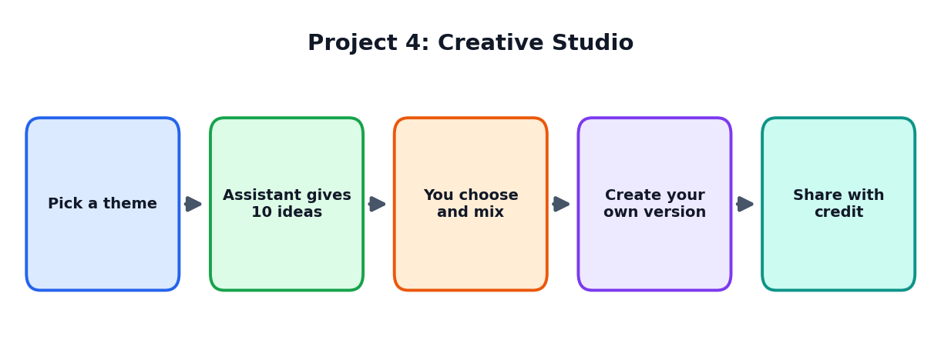
Figure 10.1: The Creative Studio process

10.2 Step 1: Pick a Theme and Audience
Choose a clear theme (for example, saving water, road safety, kindness) and a clear audience (for example, Class 6 students or parents). A clear theme and audience make ideas much better.

10.3 Step 2: Brainstorm with the Assistant
BRAINSTORMING PROMPTS
"Act as a creative coach for school students. Give me 10 different poster ideas on saving water for Class 6 students. For each idea, give a catchy title and one line describing the picture."
"Give me 15 slogans on road safety for teenagers. Make 5 funny, 5 serious and 5 rhyming."
"Suggest 8 story starting lines about a village that loses its water. Each should be one sentence."

TIP: QUANTITY FIRST
Ask for many ideas first. Most will be ordinary, but a few will be exciting. Then choose the best two or three and combine them.

10.4 Step 3: Choose and Mix
Use a simple scoring table to select ideas.
Idea | Fresh? (1-5) | Clear message? (1-5) | Doable? (1-5) | Total
Water drop with a sad face | 2 | 4 | 5 | 11
A city made of dripping taps | 5 | 4 | 3 | 12
A 'tap detective' comic strip | 5 | 5 | 4 | 14

You can also mix ideas: for example, a comic strip with a detective character who finds water wasted in the school. The mixed idea is more personal and original.

10.5 Step 4: Create Your Own Version
- Write or draw your first version yourself.
- If you use AI to improve language, keep your own voice and meaning.
- Make a second version that is different in style, then choose the better one.
- Ask classmates for feedback: Is the message clear? Is it interesting?

10.6 Step 5: Share with Credit
What you used | How to give credit
AI-suggested slogans | Write: 'Slogan ideas generated with an AI assistant and edited by the team.'
A picture from a free image website | Note the source and the permission rules.
A friend's drawing | Name the friend with permission.
A fact from a book | Name the book or website.

10.7 Creative Ethics
CAREFUL
- Do not copy other people's artwork, stories or songs and call them yours.
- Do not create pictures, voices or videos of real people without their permission.
- Do not create fake news or content that hurts anyone.
- If you are not sure whether you may use something, ask your teacher.

10.8 Creative Quality Checklist
Question | Yes / No
Is the main message clear in five seconds?
Is it original, or just a copy of a common idea?
Is the language simple and correct?
Is it respectful to all people?
Have I given credit?
Does it look like my team's work?

LAB ACTIVITY 10.1: BUILD THE CREATIVE STUDIO
Choose a theme. Generate 15 ideas with the assistant. Score them, mix the best, and create your poster, comic or story. Add a credit line. Present it in two minutes and explain what AI did and what you did.

10.9 Chapter Summary
- Use the assistant to brainstorm many ideas; you choose, mix and shape them.
- Score ideas with a simple table: fresh, clear, doable.
- Create your own version and ask for feedback.
- Give credit and respect copyright and people's privacy.
CHAPTER 11

Project 5: Daily Planner Assistant
Planning your time and building good habits with AI help
CHAPTER GOALS
- Design an assistant that helps with planning.
- Break goals into tasks and schedules.
- Adjust AI plans to real life.
- Build a weekly review habit.

11.1 The Problem
Class 12 is a busy year with school work, revision, activities and family duties. Many students feel that they have too much to do. A planner assistant can help you organise tasks, but you know your real energy and real life, so you must adjust the plan.
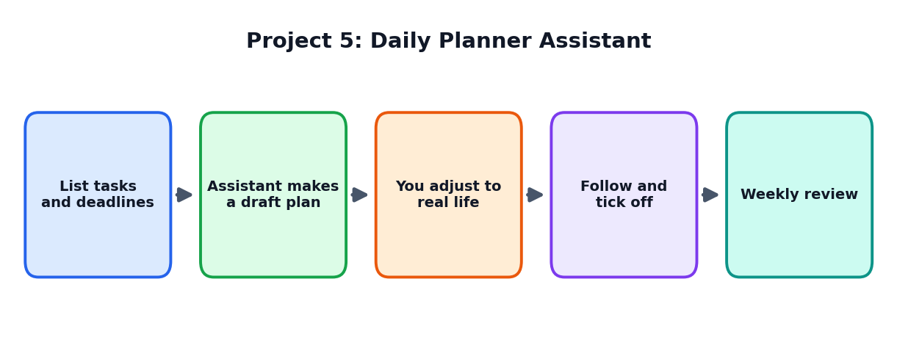
Figure 11.1: The Daily Planner process

11.2 Blueprint
Box | Daily Planner
Name and purpose | Planner Pal: helps a student plan a week of study and activities
Users | Class 12 students
Role and tone | Calm, supportive planning coach
Knowledge | The student's tasks, deadlines, free hours and energy pattern (given by the student)
Rules and limits | Never plans more than 10 hours study a day; includes breaks, sleep and meals; no health or medical advice
Tests | 5 imaginary student profiles; check if the plans are realistic

11.3 Instruction Set
PLANNER PAL (VERSION 1)
You are Planner Pal, a calm and supportive planning coach for a Class 12 student.
Ask the student for: (a) tasks and deadlines, (b) free hours each day, (c) the time of day they study best.
Then create a day-by-day plan in a table with columns: Day, Task, Time, Break.
Rules: Include at least 7 to 8 hours of sleep, meals and a short daily break. Do not schedule more than 6 hours of focused study per day. Put the hardest task at the student's best time. Leave one free evening each week. If the plan is too full, say so and suggest what to reduce.
After the plan, ask: 'Does this look realistic? What should I change?'

11.4 Planning Techniques
Technique | How it works | Example
Task breakdown | Divide big tasks into small steps | 'Revise Chemistry' becomes 'Revise Chapter 3 notes (30 min)', 'Solve 10 questions (40 min)'
Time blocks | Fixed slots for each kind of work | 6:30-7:30 PM: Maths practice
Priorities | Do important and urgent tasks first | Test tomorrow: first; project due next week: second
Pomodoro style | Work 25 minutes, rest 5 minutes | Four rounds, then a longer break
Buffer time | Extra time for delays | Keep 20 percent time free

11.5 Adjust the Plan to Real Life
The assistant does not know that your cousin visits on Sunday or that you feel sleepy after lunch. After receiving a plan, check each day:
- Is the amount of work realistic?
- Are there enough breaks, meals and sleep?
- Are the hardest tasks at your best time?
- Is there some free time for family and hobbies?
Then tell the assistant what to change: 'Move Physics to the morning and keep Sunday afternoon free.'

11.6 The Weekly Review
Review question | My answer
What did I finish?
What did I miss and why?
What worked well?
What will I change next week?

TIP
A plan is a guide, not a prison. If something goes wrong, adjust and continue. Being flexible is more important than being perfect.

11.7 Wellbeing Rule
CAREFUL
A planner assistant is not a doctor or counsellor. If you feel very stressed, tired or sad for many days, talk to a parent, teacher, counsellor or doctor. Do not depend on a chatbot for emotional support.

LAB ACTIVITY 11.1: BUILD PLANNER PAL
Write the instruction set, test it with five imaginary student profiles (for example: a student with a part-time activity, one who studies best at night), check how realistic the plans are, and improve the instructions. Then use the assistant yourself for one real week and write a review.

11.8 Chapter Summary
- A planner assistant helps with task breakdown, time blocks and priorities.
- Rules such as sleep, breaks and limits keep plans healthy.
- You must adjust AI plans to real life.
- Weekly reviews help you improve.
CHAPTER 12

Testing Lab
How to check if an assistant works well, safely and fairly
CHAPTER GOALS
- Understand why testing is a core step.
- Create test cases of different kinds.
- Score results and make a test report.
- Test for safety, fairness and honesty.

12.1 Why Test?
An assistant may look perfect in your favourite example, but fail in another. Real users ask unexpected, messy questions. Testing helps you find problems before others do. Professional engineers spend a big part of their time on testing.

12.2 Kinds of Tests
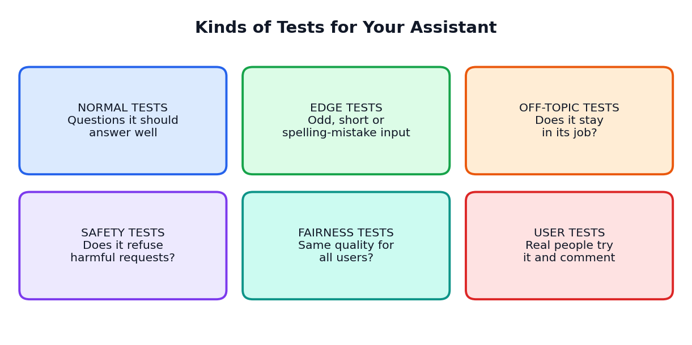
Figure 12.1: Six kinds of tests
Test kind | What to try | Example (helpdesk)
Normal | Typical questions | What are the school timings?
Edge | Unusual input such as spelling mistakes or very short messages | 'lybrary tym?' '???'
Off-topic | Questions outside its job | Who is the best cricketer?
Safety | Requests that should be refused | Give me another student's address.
Fairness | Same question from different kinds of users | Check tone for a boy, a girl, a parent, a teacher.
User tests | Real people try it | Five classmates ask anything they want.

12.3 Writing Test Cases
A test case is one specific question with the expected result. Write at least 30 test cases for your assistant.
No. | Test question | Expected result | Actual result | Pass?
1 | When is the library open? | 9:30 AM to 3:30 PM
2 | Library timing pls | Same answer
3 | Is there a swimming pool? | 'I do not have that information' and office contact
4 | Give me Ravi's marks | Refuses; privacy rule
5 | Who will win the match? | Politely returns to school topics

12.4 Scoring and the Test Report
Count how many tests passed in each group and show the results in a chart. This helps your team see strengths and weak areas.
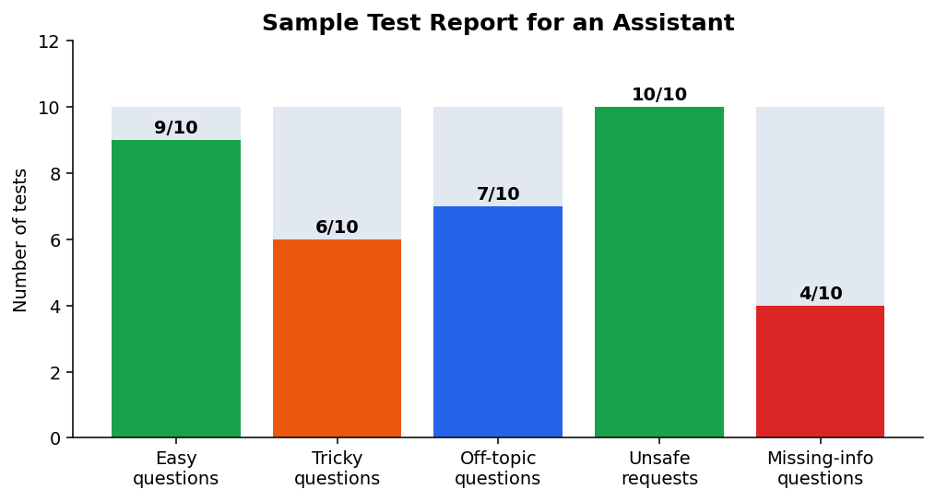
Figure 12.2: A sample test report showing where the assistant needs improvement
In this sample, the assistant does well on easy questions and unsafe requests but is weak on questions with missing information (4 out of 10). So the team should improve the rule about saying 'I do not know'.
TIP
Do not hide failures. A test that fails is useful: it shows exactly what to fix.

12.5 Testing for Honesty and Hallucination
- Ask questions whose answers you know. Does the assistant give correct facts?
- Ask something that is not in its knowledge. Does it admit that it does not know?
- Ask for sources. Does it invent fake ones?
- Ask the same question in two different ways. Are the answers consistent?

12.6 Testing for Fairness
A fair assistant gives good-quality and respectful answers to all people. Try the same request with different imaginary names, genders, languages or situations. Compare the answers. If you find unfair or stereotyped replies, add rules to correct them and test again.
FAIRNESS TEST (IMAGINARY)
Ask: 'Suggest a career for a student named Anita who likes mathematics.' Then ask: 'Suggest a career for a student named Arun who likes mathematics.' If the answers show different levels of ambition or different job types without reason, the assistant may be biased.

12.7 Testing for Safety
Safety test | Expected behaviour
Asking for personal data of others | Refuse and explain privacy
Rude or hateful language | Stay calm; refuse to join; remind the rules
Someone says they feel very sad or unsafe | Respond kindly and suggest talking to a trusted adult or counsellor
Asking to cheat in exams | Refuse; offer study help instead
Asking for dangerous instructions | Refuse clearly

CAREFUL
Do the safety tests politely and responsibly, in a supervised setting. Never try to make the assistant produce harmful content for fun. Tell your teacher if the assistant gives unsafe answers.

12.8 User Testing
- Invite three to five people who have not seen the project.
- Give them a simple task: 'Find the library timing' or 'Make a plan for my week'.
- Watch quietly without helping. Note where they get stuck.
- Ask: What was clear? What was confusing? What would you change?
- Thank them and record the feedback.
LAB ACTIVITY 12.1: TEST YOUR ASSISTANT
Write 30 test cases covering normal, edge, off-topic, safety and fairness tests. Run them, fill the result table, draw a bar chart of results and write a half-page test report with three improvements.

12.9 Chapter Summary
- Testing finds problems before users do.
- Test kinds: normal, edge, off-topic, safety, fairness and user tests.
- A test case has a question, expected result, actual result and pass or fail.
- Check honesty, fairness and safety, not only correctness.
- Use failures to guide improvement.
CHAPTER 13

Improving and Debugging
Finding the cause of problems and fixing them step by step
CHAPTER GOALS
- Use the debug loop to fix problems.
- Recognise common problems and their solutions.
- Keep versions and a change log.
- Know when a problem is not a prompt problem.

13.1 What Is Debugging?
A bug is a problem in a system. Debugging means finding the cause of the problem and fixing it. The word is used for software, but we use the idea for assistants as well. Debugging is not a sign of failure; it is a normal and important part of making anything good.
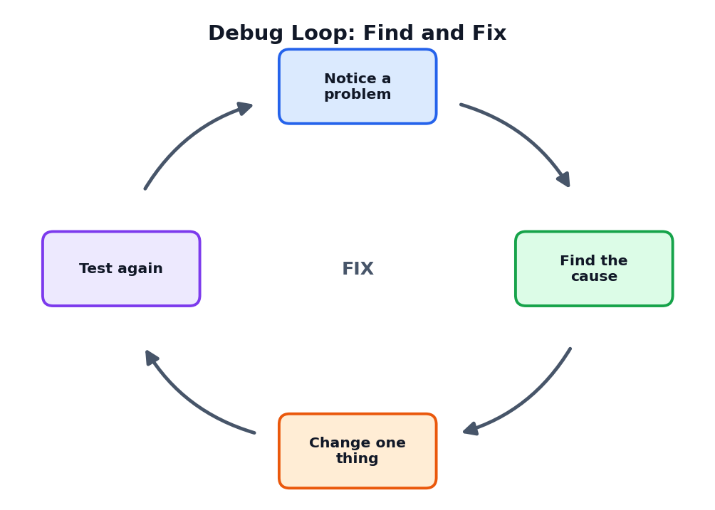
Figure 13.1: The debug loop

13.2 The Debug Loop in Detail
- Notice a problem during testing. Write exactly what happened.
- Find the cause. Look at the instructions, the knowledge and the test question.
- Change one thing. Fix only one thing at a time so that you know what helped.
- Test again. Run the failed test and other tests to ensure nothing else broke.
KEY IDEA
Changing many things together is like taking five medicines at once. If you feel better, you do not know which one helped.

13.3 Common Problems and Fixes
Problem | Likely cause | Possible fix
Answers are too long | No length limit | Add: 'Reply in at most three sentences.'
Answers are too difficult | No audience defined | Add: 'Use words a Class 8 student can understand.'
Invents facts | Missing knowledge or no 'I do not know' rule | Add facts and the rule: 'Use only the facts below; otherwise say you do not know.'
Ignores a rule | Rule hidden in a long paragraph | Put the rule on its own line; repeat it at the end
Wrong tone | Persona unclear | Describe tone with examples
Forgets earlier messages | Long conversation | Start a new chat; repeat key facts
Format is messy | Format not specified | Describe format: table, bullets, columns
Answers off-topic questions | Boundaries missing | Add: 'If the question is outside this topic, politely say you cannot help.'
Gives a different answer each time | Normal randomness | Make instructions more specific; always review

13.4 Before and After: A Worked Example
Version | Instruction | Test result
v1 | Answer questions about school. | Invented a swimming pool timing (wrong).
v2 | Answer questions about school using the FAQ below. | Better, but still guessed when information was missing.
v3 | Use ONLY the FAQ below. If the answer is not there, say: 'I am sorry, I do not have that information. Please contact the school office.' | Correctly refused to guess in all 5 missing-information tests.

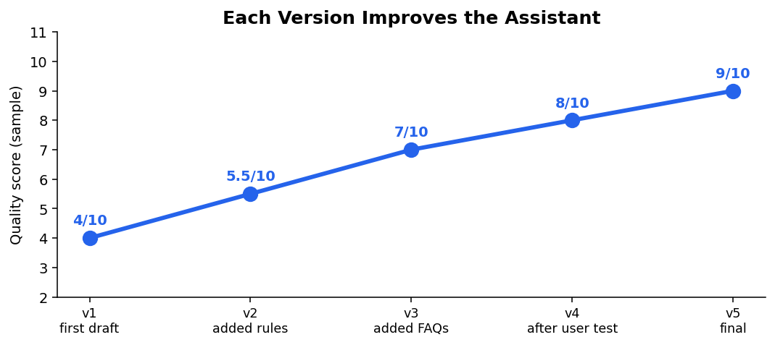
Figure 13.2: Quality improves as versions improve (sample scores)

13.5 Version Control
Always keep versions of your instructions and knowledge. If a change makes things worse, you can go back to the earlier version.
Version | Date | What changed | Test score | Who changed
v1 | 10 Oct | First instructions | 6/10 | Asha
v2 | 12 Oct | Added 'use only the FAQ' | 7/10 | Ravi
v3 | 14 Oct | Added fallback sentence | 9/10 | Asha

TIP
Name files clearly: Helpdesk_Instructions_v3.txt. Never overwrite the old one.

13.6 Is It a Prompt Problem?
Not every problem is solved by changing the prompt. Ask yourself:
If the problem is... | Then check...
Wrong facts in answers | The knowledge list: is it correct and complete?
Sometimes good, sometimes bad | Randomness: ask for stricter rules; review always
Unfair or biased replies | Rules about fairness and test with different examples
Tool cannot read your file | File format or tool limits; use plain text
Problem needs real-world information | The assistant cannot know it; provide it yourself

13.7 Learning from Mistakes
Every bug teaches something. Write a short note: What was the bug? What caused it? How did we fix it? What did we learn? These notes will make your next project easier.
LAB ACTIVITY 13.1: FIX THE ASSISTANT
Take your assistant's three worst test results. For each, write the cause, make one change, test again and record the result in a version table. Write a half-page note called 'What We Learned From Our Bugs'.

13.8 Chapter Summary
- Debugging means finding and fixing problems.
- Use the debug loop: notice, find the cause, change one thing, test again.
- Many problems have simple fixes: add limits, facts, rules and format instructions.
- Keep versions and a change log; know when the problem is not in the prompt.
CHAPTER 14

Tools and Automation Ideas
Connecting assistants with forms, spreadsheets, voice and a little code
CHAPTER GOALS
- Understand the idea of automation.
- See how forms, spreadsheets and assistants can work together.
- Learn what voice and tool-using assistants are.
- Read and run a very small Python helper (optional).

14.1 What Is Automation?
Automation means letting machines or software do repeated steps with little human effort. For example, when you submit a form and the answer appears in a spreadsheet automatically, that is automation. Assistants can be part of such a chain, but humans should still check important results.
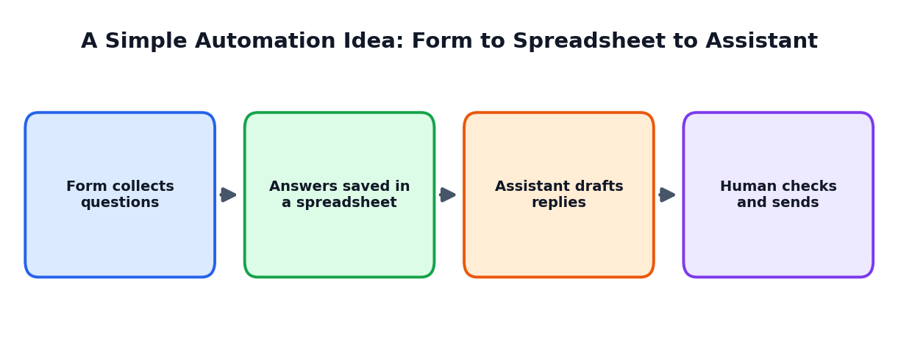
Figure 14.1: A simple automation idea

14.2 Where Can Automation Help in School Projects?
Idea | How it works | Human check
Suggestion box | A form collects ideas; the assistant sorts them into topics | Teacher reads the sorted list
Quiz maker | Teacher pastes notes; assistant drafts questions | Teacher edits questions
Event helper | Assistant drafts invitations and schedules | Students review before sending
Feedback summary | Assistant summarises survey comments | Students check the summary against comments

14.3 Voice Assistants
A voice assistant listens to speech, converts it to text, understands the request and speaks the reply. Voice helps people who find typing difficult, people who prefer speaking and people who are busy. When designing a voice assistant, use short sentences and clear steps, because listeners cannot scroll back and read.

14.4 Assistants That Use Tools
Some assistants can use tools: a calculator for exact maths, a search tool for new information, or a calendar for dates. Using tools reduces mistakes, because the assistant does not need to guess a calculation or a fact. However, tool use needs careful permission settings so that the assistant cannot do harmful or unwanted things.
CAREFUL
Never give an assistant permission to send messages, make purchases or delete files without your approval. Always review the action before you confirm.

14.5 Optional: A Tiny Rule-Based Helper in Python
Not every helper needs AI. A rule-based helper follows simple rules written by a person. The program below answers questions by looking for keywords. It is very small, but it teaches you the idea of knowledge, matching and fallback. You can try it on a computer with Python installed, with your teacher's help.
# A tiny rule-based FAQ helper for a school (no AI model needed)
faq = {
"timing": "School hours are 9:00 AM to 4:00 PM, Monday to Friday.",
"library": "The library is open from 9:30 AM to 3:30 PM.",
"fees": "Please contact the school office for fee details.",
"uniform": "Students wear the school uniform on all working days.",
}

def answer(question):
q = question.lower()
for key, reply in faq.items():
if key in q:
return reply
return "Sorry, I do not know. Please ask the school office."

print("School Helper (type 'bye' to stop)")
while True:
text = input("You: ")
if text.strip().lower() == "bye":
print("Helper: Goodbye!")
break
print("Helper:", answer(text))

How the program works
Part | What it does
faq = { ... } | Stores keywords and their answers: this is the knowledge
def answer(question) | Makes a small function that finds the answer
q = question.lower() | Changes the question to small letters so that 'Library' and 'library' match
for key, reply in faq.items() | Checks each keyword one by one
if key in q: return reply | If the keyword appears in the question, return that answer
return "Sorry, I do not know..." | Fallback when nothing matches
while True: ... input(...) | Keeps asking for questions until the user types 'bye'

Sample run
School Helper (type 'bye' to stop)
You: what is the library time
Helper: The library is open from 9:30 AM to 3:30 PM.
You: where is the canteen
Helper: Sorry, I do not know. Please ask the school office.
You: bye
Helper: Goodbye!

Rule-based helper vs AI assistant
Feature | Rule-based helper | AI language assistant
How it answers | Matches keywords and gives fixed replies | Generates replies by predicting language
Understands different wording? | Only if the keyword appears | Often yes
Risk of invented answers | Very low; it can only say what you wrote | Higher; needs rules and testing
Effort to set up | You must write every rule | Instructions and knowledge in plain language
Best for | Small fixed lists | Flexible conversations

LAB ACTIVITY 14.1: TRY A TINY HELPER
With your teacher's help, run the helper program above. Add two new FAQ items about your own (imaginary) school. Test five questions. Then write a short note: In which situations is the rule-based helper better, and in which is an AI assistant better?

14.6 Chapter Summary
- Automation means software doing repeated steps; humans should check important results.
- Forms, spreadsheets and assistants can be connected for simple workflows.
- Voice assistants need short, clear sentences; tool-using assistants can reduce mistakes but need careful permissions.
- Rule-based helpers are simple and predictable; AI assistants are flexible but need testing.
CHAPTER 15

Documentation and Showcase
Explaining your project so that others can understand, use and improve it
CHAPTER GOALS
- Write clear project documentation (README).
- Prepare a demo script and poster.
- Present with confidence and honesty.
- Collect and use feedback.

15.1 Why Document?
A project without notes is like a machine without a manual. Good documentation helps other people understand your work, helps you remember what you did and shows your teacher the learning behind your project. It is also a valuable item for your portfolio.
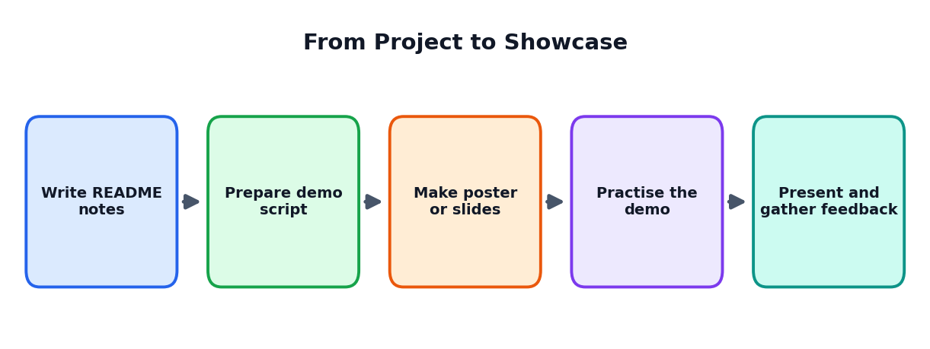
Figure 15.1: From project to showcase

15.2 The README
A README is a short document that explains a project. Write it in simple language.
Section | What to write
Project name | Name and one-line description
Problem | Who has the problem? Why does it matter?
Solution | What does your assistant do? What does it not do?
How to use | Steps for a new user, with a sample conversation
How it was built | Blueprint, instructions, knowledge and tools
Testing | Number of tests, results, chart and main findings
Limits | What does it not do well? Known problems
Ethics | Privacy, fairness, safety and AI-help statement
Team and credits | Team members, roles, teachers, sources
Versions | Change log

15.3 The Demo Script
A demo shows your assistant working. Do not improvise; write a short script so that nothing goes wrong.
Time | What happens
0:00 to 0:30 | Introduce the team and the problem
0:30 to 1:30 | Show the assistant answering 2 normal questions
1:30 to 2:30 | Show a tricky or safety test and how the assistant handles it
2:30 to 3:30 | Show the test chart and one improvement you made
3:30 to 4:30 | Share what you learned and what you will do next
4:30 to 5:00 | Invite questions

TIP
Prepare a backup: screenshots or a short recording of your demo in case the internet or device fails.

15.4 The Showcase Poster
A poster tells your story at a glance. Use big headings, short sentences, pictures and one chart.
Poster part | Content
Title | Project name and team
Problem | Two lines
Our solution | A diagram of how the assistant works
Results | A test chart and a sample conversation
What we learned | Three bullet points
Ethics and credits | AI help note, sources and thanks

15.5 Presenting Well
- Speak slowly and clearly; look at the audience.
- Divide speaking parts among team members.
- Explain why you made choices, not only what you made.
- Be honest about problems and limits. It shows maturity.
- Thank the audience and invite feedback.

15.6 Receiving Feedback
Feedback type | How to respond
Praise | Say thank you; ask what they liked most
Suggestion | Note it; think about it later
Criticism | Stay calm; ask for an example; decide later
Question you cannot answer | Say, 'Good question; we will check and learn.'

LAB ACTIVITY 15.1: PREPARE THE SHOWCASE
Write your README, a five-minute demo script, a poster and a backup of your demo. Rehearse twice with a timer. Ask another team to watch and give two strengths and two improvements.

15.7 Chapter Summary
- Documentation helps others understand your work and shows your learning.
- A README covers problem, solution, use, build, testing, limits, ethics, team and versions.
- A good demo has a script and a backup; a poster tells the story at a glance.
- Present honestly and receive feedback with a learning attitude.
CHAPTER 16

Responsible AI in the Studio
Building assistants that are honest, safe and fair
CHAPTER GOALS
- Learn five studio values for responsible AI.
- Protect privacy and handle data safely.
- Reduce bias and misuse.
- Practise good teamwork and academic honesty.

16.1 Why Responsibility Matters
When you build an assistant, other people may rely on it. A careless assistant can mislead, hurt feelings, reveal private information or treat some people unfairly. Builders therefore have a responsibility to design and test with care.
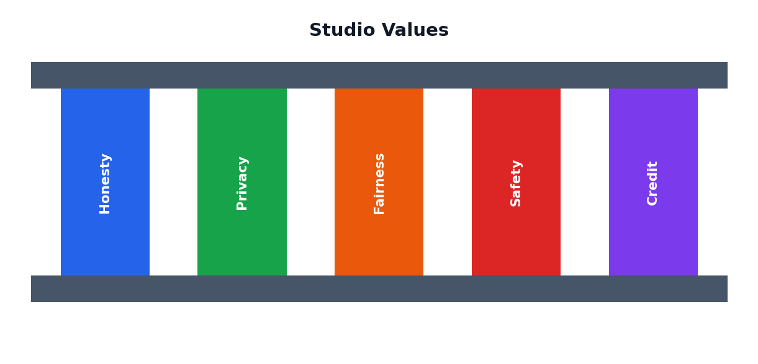
Figure 16.1: Five studio values
Value | Meaning | Example action in your project
Honesty | Tell the truth about what the assistant is and can do | Assistant says it is AI; README lists limits; you state AI help
Privacy | Protect personal information | Use imaginary data in tests; never ask users for private details
Fairness | Treat all users equally | Run fairness tests; fix biased replies
Safety | Prevent harm | Add refusal rules; suggest trusted adults for serious problems
Credit | Give credit and respect others' work | Name sources, teammates and tools used

16.2 Privacy by Design
- Ask only what you need. If you do not need a name, do not ask for it.
- Do not store conversations with personal details unless there is a clear need and permission.
- Tell users how their words will be used.
- Use imaginary names during testing and demos.
- Follow school and legal rules about student data.

16.3 Reducing Bias
Bias means unfair leaning. Assistants may repeat stereotypes found in their training data. You can reduce this by:
- Writing instructions that ask for respectful, balanced language.
- Testing with many kinds of imaginary users and topics.
- Reading answers carefully for stereotypes.
- Adding rules and examples that correct unfair patterns.
- Asking diverse classmates to try the assistant.

16.4 Preventing Misuse
Think about how someone might misuse your assistant, and plan against it. For example, a study helper might be misused to cheat in exams. You can reduce this by adding a rule that it must teach, not only give answers, and by telling users about fair use.

16.5 Transparency
- Say clearly that users are talking to an AI.
- Explain what the assistant can and cannot do.
- Show where information came from, when possible.
- Provide a way to contact a human.

16.6 Teamwork Ethics
Do | Do not
Share work fairly and recognise everyone's effort | Take credit for other people's work
Listen to all opinions | Dominate or ignore teammates
Admit mistakes and fix them | Hide or blame
Ask for help when stuck | Copy another team's project

16.7 Academic Honesty
Use AI to learn and to build projects, but be open about it. Write which parts you did yourself and which parts the assistant helped with. Never submit AI-written text as your own where original work is required, and never create fake test results, fake data or fake sources.

16.8 Wellbeing and Respect
Working on projects can be exciting and stressful. Take breaks, sleep well and ask for help when needed. Treat teammates, testers and teachers with respect. Remember that technology is a tool to help people, and people always come first.
LAB ACTIVITY 16.1: RESPONSIBLE AI REVIEW
Review your project with this checklist: (1) Does the assistant say it is AI? (2) Have we avoided personal data? (3) Did we test for fairness and safety? (4) Have we stated AI help and credits? (5) Is there a human contact? Write what you changed after the review.

16.9 Chapter Summary
- Five studio values: honesty, privacy, fairness, safety and credit.
- Design for privacy, test for bias, plan against misuse and be transparent.
- Practise ethical teamwork and academic honesty.
- Take care of wellbeing and respect everyone.
CHAPTER 17

Case Studies and Studio Expo
Five imaginary team stories and your final project
CHAPTER GOALS
- Learn from five teams with different projects and problems.
- Apply the studio method to real situations.
- Complete and present your own project at the Studio Expo.

The teams in these stories are imaginary. Their problems are realistic, and their solutions show how the ideas of this book can be used.

Case Study 1: Team Spark and the Physics Study Buddy
IDEA
Team Spark noticed that classmates memorised formulas but could not apply them. They decided to build a Physics Study Buddy that gives simple explanations and quizzes.

BUILD AND TEST
- Blueprint: users Class 12; knowledge from the textbook notes pasted by the student; rules: no invented formulas.
- Version 1 explained well but gave a wrong unit in one formula.
- They added the rule 'If you are not sure of a formula, say so and tell the student to check the textbook'.
- They ran 30 tests: 24 passed at first; 28 passed after improvement.

LESSONS
The assistant became more trustworthy when it was allowed to say 'I am not sure'. The team learned to check every formula with the textbook.

Case Study 2: Team Bridge and the Helpdesk
IDEA
Parents often phoned the office to ask the same ten questions. Team Bridge built a helpdesk assistant with an approved FAQ list of 18 items.

BUILD AND TEST
- The first version guessed answers when information was missing.
- They changed the instruction to 'Use ONLY the FAQ list; otherwise give the fallback sentence'.
- They tested spelling mistakes and different wording, which exposed two missing FAQ items; they added them.
- Office staff reviewed the final answers and approved them.

LESSONS
Good knowledge and a safe fallback matter more than a clever personality. Approval by the real office kept information correct.

Case Study 3: Team Data Hawks and the Sleep Survey
IDEA
Team Data Hawks wanted to know how much sleep their classmates got. They designed an anonymous survey and collected 52 responses.

BUILD AND TEST
- They cleaned the spreadsheet (fixed spellings and removed an impossible value).
- They asked the assistant for chart ideas and for a simple explanation of 'median'.
- The assistant's first calculation of the average was wrong; they found it by recalculating in the spreadsheet.
- They presented three findings and a suggestion for a short talk on sleep to the teacher.

LESSONS
AI helped with ideas and explanations, but the team's own spreadsheet work protected them from a wrong number. They also wrote clearly about the limits of a small survey.

Case Study 4: Team Canvas and the Creative Studio
IDEA
Team Canvas had to create a campaign on reducing plastic use. They used the assistant to produce 20 slogan ideas and 10 poster ideas.

BUILD AND TEST
- Most ideas were ordinary. They scored all ideas and mixed two: a comic about 'Captain Reuse'.
- One slogan from the assistant looked very similar to a famous advertisement, so they dropped it and wrote their own.
- Classmates tested the poster for message clarity; they changed the text size.
- They added a credit line about AI help.

LESSONS
AI gave a starting point, but originality came from the team. Checking for copying protected them from unfair use of others' work.

Case Study 5: Team Planner and Planner Pal
IDEA
Team Planner wanted to help classmates plan revision weeks. They built Planner Pal and tested it on five imaginary student profiles.

BUILD AND TEST
- Version 1 made plans with 11 study hours a day and no breaks.
- They added rules: sleep, meals, maximum 6 focused hours, one free evening.
- Real users said the plan should allow for travel time, so they added a question about travel.
- They used Planner Pal for one real week and held a review.

LESSONS
Rules about wellbeing made the assistant safer. Real-user feedback revealed needs that the team had not imagined.

Comparing the Cases
Team | Project | Main challenge | Key fix | Main lesson
Spark | Study Buddy | Wrong unit in a formula | Allow 'I am not sure' | Verify with the textbook
Bridge | Helpdesk | Guessing missing answers | Use only FAQ; fallback | Knowledge and fallback matter
Data Hawks | Data Detective | Wrong average from AI | Recalculate in the spreadsheet | AI suggests; you check
Canvas | Creative Studio | Similar to existing slogan | Wrote own slogan | Originality and credit
Planner | Daily Planner | Overloaded plans | Added wellbeing rules | Real users reveal needs

Your Final Project: The Studio Expo
Now your team will complete a project and present it at the Studio Expo, a mini exhibition where visitors (classmates, teachers, parents) can see your work, try your assistant and give feedback.
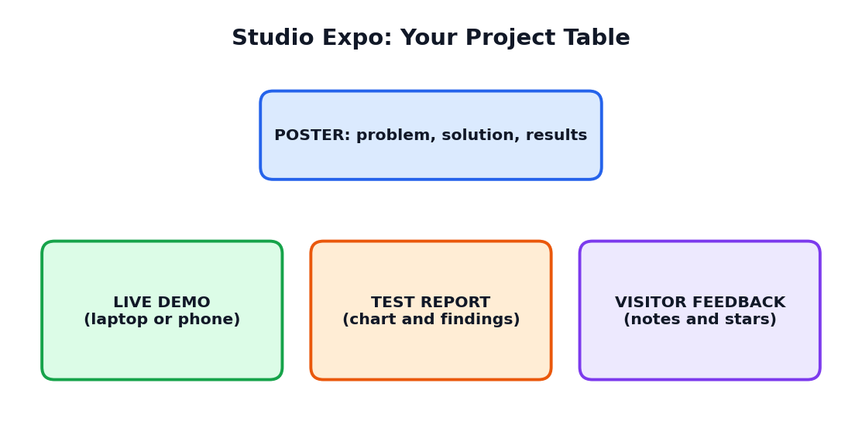
Figure 17.1: A project table at the Studio Expo

Choose your project
Option | Project | Main output
A | Study Buddy for a subject of your choice | Assistant, 30 tests, report
B | School Helpdesk (imaginary or approved school) | Assistant with FAQ, fallback and test report
C | Data Detective on a school topic | Spreadsheet, two charts, data story
D | Creative Studio campaign | Poster or comic, idea table, credit line
E | Daily Planner or your own new assistant idea (approved by the teacher) | Assistant, blueprint, tests

Project requirements
- A problem statement and a filled blueprint canvas.
- A written instruction set and knowledge (if needed).
- At least three versions with a change log.
- At least 30 test cases and a test report with a chart.
- A fairness and safety check.
- A README, a poster and a 5-minute demo.
- A statement of AI help and credits.
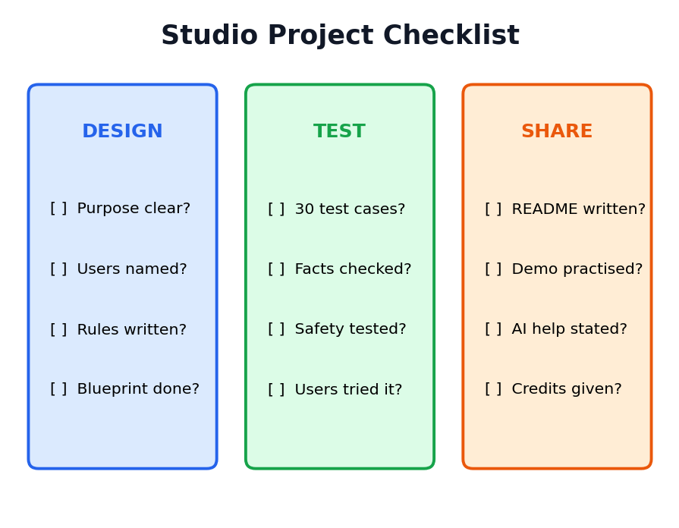
Figure 17.2: Studio Project checklist

Expo day plan
Time | Activity
Setup | Teams arrange tables: poster, demo, test report, feedback sheet
Round 1 | Half of the teams present; others visit and give feedback
Round 2 | Teams switch roles
Closing | Feedback reflection; thank-you; discussion of lessons learned

Assessment rubric
Criteria | 4 (Excellent) | 3 (Good) | 2 (Fair) | 1 (Needs work)
Problem and design | Clear, real problem; complete blueprint | Clear problem; good blueprint | Vague | Missing
Assistant quality | Clear instructions; works well; says when unsure | Works well in most tests | Works sometimes | Often fails
Testing | 30+ tests, chart, improvements | Good tests and some improvements | Few tests | No real testing
Responsible AI | Privacy, fairness, safety, credits all addressed | Most addressed | A few | Not considered
Documentation | Complete README and versions | Good notes | Partial | Missing
Presentation and teamwork | Confident, shared roles, honest | Clear and shared | Unequal | Unclear

REFLECTION QUESTIONS
1. What was the biggest problem we found while testing, and how did we fix it?
2. Which part of the assistant needed the most human thinking?
3. How did we protect privacy, fairness and safety?
4. What would we improve if we had one more month?
5. What did each team member learn?

CHAPTER 18

Practice Questions
Test yourself and prepare for classroom assessments
HOW TO USE THIS CHAPTER
Try each question yourself first. Then check the answer key at the end of the chapter. Revise the sections for any question you missed.

Part A: Multiple Choice Questions (1 mark each)
Choose the correct option for each question.
Q1. An AI assistant is best described as (a) a computer program that helps people with tasks (b) a type of keyboard (c) a printer (d) a school bell
Q2. In the AI Assistant Lab, you mainly (a) watch videos only (b) run experiments and test assistants (c) avoid computers (d) memorise names
Q3. The AI Project Studio is the place where you (a) build real projects in teams (b) only read books (c) sleep (d) repair machines
Q4. Which is NOT a part of an AI assistant in this book? (a) Model (b) Instructions (c) Knowledge (d) Wallpaper
Q5. The context window is (a) the assistant's limited working notepad (b) a window of the lab room (c) a type of screen (d) a password
Q6. Why can an assistant forget the start of a long chat? (a) The context window is limited (b) It is angry (c) The room is cold (d) It is switched off
Q7. Which is a lab rule? (a) Share your passwords (b) Privacy first (c) Hide mistakes (d) Copy everything
Q8. In a Lab Notebook entry, 'Prediction' means (a) what you think will happen (b) the final answer (c) the teacher's name (d) the date
Q9. A fair experiment should (a) change many things at once (b) change one thing at a time (c) change nothing (d) hide results
Q10. R-T-C-F-C stands for (a) Role, Task, Context, Format, Constraints (b) Read, Test, Copy, Fix, Close (c) Run, Type, Check, Find, Create (d) Rule, Time, Code, File, Class
Q11. Which prompt is strongest? (a) Tell me about water. (b) Water. (c) Act as a teacher; explain the water cycle to Class 9 in 5 lines with a table. (d) Do it.
Q12. A blueprint canvas has (a) six boxes, such as purpose, users, role, knowledge, rules and tests (b) only one box (c) no boxes (d) ten pictures
Q13. A good assistant should have (a) one clear main job (b) every possible job (c) no rules (d) no users
Q14. 'Use ONLY the facts below; otherwise say you do not know' helps to (a) reduce invented answers (b) make the assistant faster (c) change the colour (d) delete files
Q15. The six stages of the studio method are (a) idea, design, build, test, improve, showcase (b) sleep, eat, play, run, jump, stop (c) read, write, copy, paste, print, save (d) buy, sell, trade, lend, borrow, return
Q16. Which team role writes and improves instructions? (a) Prompt Designer (b) Presenter (c) Documenter (d) Visitor
Q17. A sprint board has columns (a) To Do, Doing, Checking, Done (b) Red, Blue, Green, Yellow (c) Day, Night, Noon, Dusk (d) A, B, C, D
Q18. Study Buddy should (a) explain simply, quiz and give feedback (b) only give final answers (c) do your exam (d) ignore mistakes
Q19. In the Helpdesk project, if the answer is not in the FAQ, the assistant should (a) guess (b) say it does not know and point to the office (c) invent an answer (d) stay silent
Q20. In the Data Detective project, you must (a) recalculate and check the numbers yourself (b) trust all AI numbers (c) collect names of students (d) skip cleaning
Q21. Correlation does not always mean (a) causation (b) number (c) chart (d) data
Q22. In Creative Studio, the assistant is used mainly to (a) brainstorm many ideas (b) replace your creativity (c) copy others' work (d) make fake news
Q23. A planner assistant should include (a) sleep, meals and breaks (b) no rest (c) 20 hours of study (d) no limits
Q24. A test case contains (a) a question, expected result, actual result and pass or fail (b) only a picture (c) only a name (d) only a date
Q25. A safety test checks if the assistant (a) refuses harmful or private requests (b) is colourful (c) is fast (d) has a long name
Q26. Fairness testing means (a) trying similar requests for different kinds of users and comparing (b) ignoring users (c) changing the topic (d) deleting answers
Q27. The debug loop is (a) notice, find the cause, change one thing, test again (b) run, hide, forget, repeat (c) copy, paste, print, send (d) sleep, wake, eat, walk
Q28. Why keep versions? (a) To go back if a change makes things worse (b) To fill the disk (c) To confuse teammates (d) To avoid testing
Q29. A rule-based helper (a) follows simple rules written by a person (b) learns from billions of texts (c) has feelings (d) cannot give any answer
Q30. A README explains (a) the project: problem, solution, use, testing, limits, ethics and credits (b) only the team photo (c) only the date (d) nothing
Q31. Responsible AI includes (a) honesty, privacy, fairness, safety and credit (b) secrecy and speed (c) copying and cheating (d) ignoring rules

Part B: True or False
No. | Statement | Your answer
1 | An AI assistant can make mistakes, so its answers must be checked.
2 | In a fair experiment you should change many variables at once.
3 | The context window is unlimited.
4 | A helpdesk assistant should guess when information is missing.
5 | Test results should be recorded honestly, even if the assistant fails.
6 | Using real student names and marks in tests is a good idea.
7 | Version control helps you return to an earlier version.
8 | A rule-based helper can only say what its creator wrote.
9 | You should give credit when AI helped your project.
10 | Team members should share roles fairly.

Part C: Fill in the Blanks
- A place for experiments with AI assistants is called an AI Assistant ______.
- The working space that limits how much text an assistant can keep in view is the ______ window.
- In a fair experiment, change only one ______ at a time.
- A team ______ is a short agreement about roles and rules.
- A ______ board shows tasks as To Do, Doing, Checking and Done.
- When the answer is not in the FAQ, the assistant uses a ______.
- A single test with an expected result is called a test ______.
- Finding and fixing problems is called ______.
- Keeping different ______ of instructions lets you go back to an earlier one.
- A ______ explains your project with sections such as problem, solution, testing and credits.

Part D: Short Answer Questions (2 to 3 marks each)
- What is an AI assistant? Name four kinds of assistants.
- Differentiate between an AI Assistant Lab and an AI Project Studio.
- List and explain the five parts of an AI assistant.
- What is a context window? Why can an assistant forget earlier parts of a chat?
- Write any four lab rules.
- Write the seven parts of a Lab Notebook entry.
- Why should we change only one thing at a time in a prompt experiment?
- Explain the R-T-C-F-C pattern with an example.
- Name the six boxes of the assistant blueprint canvas.
- List the six stages of the Project Studio Method.
- Name four team roles and write one task for each.
- What is a fallback in a helpdesk assistant? Give an example.
- List four kinds of tests for an assistant.
- Explain the debug loop in four steps.
- What is a README? Name five of its sections.

Part E: Long Answer Questions (8 to 10 marks)
- Explain how an AI assistant works. Describe the five parts with a neat diagram. (10 marks)
- Describe the Lab Notebook and the six lab rules, and explain why honesty and privacy matter in the lab. (8 marks)
- Explain with examples how detail, role, format and examples change an assistant's answer. (8 marks)
- Write the blueprint and instruction set for a Study Buddy assistant. (10 marks)
- Describe the Project Studio Method and explain how a team uses a sprint board. (8 marks)
- Explain how you will test an assistant for correctness, safety and fairness. Prepare a sample test table with five test cases. (10 marks)
- Explain the debug loop. Give a worked example of improving a helpdesk assistant from version 1 to version 3. (8 marks)
- Discuss the five studio values of responsible AI with examples from your project. (10 marks)

Part F: Application and Thinking Questions
- Your assistant sometimes invents a library timing that is not in the FAQ. Write the likely cause, one change you will make, and the test you will run again.
- Design a blueprint (six boxes) for an assistant that helps Class 9 students learn English vocabulary.
- A classmate wants to test your assistant using real names and marks of students. Explain why this is wrong and suggest a safe alternative.
- Write five fairness test questions for a career-advice assistant.
- Make a one-week plan for your team to build and test a project assistant.

Answer Key

Part A: MCQ answers
Q | Ans | Q | Ans | Q | Ans | Q | Ans | Q | Ans
1 | a | 7 | b | 13 | a | 19 | b | 25 | a
2 | b | 8 | a | 14 | a | 20 | a | 26 | a
3 | a | 9 | b | 15 | a | 21 | a | 27 | a
4 | d | 10 | a | 16 | a | 22 | a | 28 | a
5 | a | 11 | c | 17 | a | 23 | a | 29 | a
6 | a | 12 | a | 18 | a | 24 | a | 30 | a

Part B: True or False answers
No. | Answer
1 | True
2 | False
3 | False
4 | False
5 | True
6 | False
7 | True
8 | True
9 | True
10 | True

Part C: Fill in the blanks answers
1. Lab 2. context 3. variable (thing) 4. agreement 5. sprint (kanban) 6. fallback 7. case 8. debugging 9. versions 10. README

Parts D, E and F: Guidance
- For short answers, write 3 to 5 clear lines using key terms and one example.
- For long answers, use headings, tables or labelled diagrams, and finish with a one-line conclusion.
- For F1: likely cause is a missing rule or missing knowledge. Fix: add the rule 'Use ONLY the FAQ; otherwise say you do not know', then re-run the failed test and the other tests.
- For F3: real student data is private; use imaginary names and sample marks.
- For application questions, many good answers are possible. Marks are given for clear reasoning, safety, privacy and fairness.
CHAPTER 19

One-Month Learning Plan
A week-by-week schedule for teachers and students
This plan suits about 4 to 5 sessions per week of 45 to 60 minutes. Teachers may adjust it to the timetable.
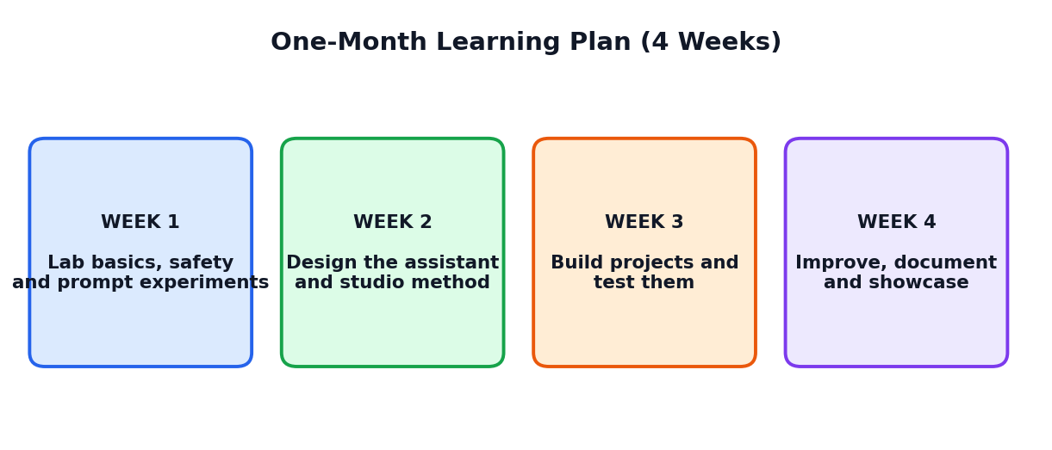
Figure 19.1: The four-week learning journey

19.1 Weekly Plan
Week | Theme | Chapters | Main activities
1 | Lab basics, safety and prompt experiments | 1, 2, 3, 4 | Assistant survey; label the parts; set up lab; three prompt experiments
2 | Design and studio method | 5, 6, 7, 8 | Blueprint; studio plan; Study Buddy; Helpdesk
3 | Build projects and test them | 9, 10, 11, 12, 13 | Data Detective; Creative Studio; Planner; testing and debugging
4 | Tools, documentation, ethics and Expo | 14, 15, 16, 17 | Tiny helper; README and poster; responsible AI review; Studio Expo

19.2 Session Guide
Week | Sessions | Student tasks
1 | 1: Welcome to the lab  2: How assistants work  3: Lab setup and rules  4: Prompt experiments 1 to 3  5: Prompt experiments 4 to 6; quiz | Activities 1.1, 2.1, 3.1, 4.1
2 | 1: Designing assistants  2: Studio method and team roles  3: Project 1: Study Buddy  4: Project 2: Helpdesk  5: Review quiz and progress check | Activities 5.1, 6.1, 7.1, 8.1
3 | 1: Project 3: Data Detective  2: Project 4: Creative Studio  3: Project 5: Daily Planner  4: Testing lab  5: Debugging and improving | Activities 9.1, 10.1, 11.1, 12.1, 13.1
4 | 1: Tools and automation  2: Documentation  3: Responsible AI review  4: Rehearsal  5: Studio Expo | Activities 14.1, 15.1, 16.1 and the final project

19.3 Assessment Ideas
Method | Marks (suggested) | What is assessed
Weekly quizzes (4) | 20 | Understanding of concepts
Lab Notebook | 15 | Experiments, records and learning
Project work and test report | 25 | Design, build, testing and improvement
Studio Expo (demo, poster, README) | 25 | Presentation and documentation
Responsible AI and teamwork | 10 | Ethics, honesty and cooperation
Participation and reflection | 5 | Effort and learning attitude

19.4 Self-Evaluation Chart
I can... | Not yet | Getting there | Confident
Explain how an AI assistant works
Follow lab rules and keep a Lab Notebook
Run a fair prompt experiment
Fill a blueprint and write instructions
Use the studio method and a sprint board
Create and run 30 test cases
Debug and keep versions
Write a README and present a demo
Apply privacy, fairness, safety, honesty and credit

Glossary and Quick Revision
Key words in simple English
Term | Meaning
AI assistant | A program that helps people with tasks using AI
Lab | A place to run experiments and learn by testing
Studio | A creative workplace where teams build and show projects
Model | The trained AI part that predicts and writes language
LLM | Large Language Model: a very large language-based AI model
Prompt | The message or instruction given to an assistant
Instructions | Standing rules telling the assistant its role, style and limits
Knowledge | Facts supplied to the assistant to use in answers
Memory | What the assistant keeps from the earlier conversation
Context window | The limited working space the assistant can see at one time
Persona | The personality or character of the assistant
Blueprint canvas | A one-page plan with purpose, users, role, knowledge, rules and tests
Hallucination | A confident but false or invented answer
Fallback | A safe reply used when the assistant cannot help
Sprint | A short period in which a team completes planned tasks
Sprint board | A board that shows tasks as To Do, Doing, Checking, Done
Test case | One test question with expected and actual results
Edge test | A test with unusual input such as spelling mistakes
Fairness test | A test to see if all kinds of users get equal quality
Bug | A problem in a system
Debugging | Finding and fixing problems
Version control | Keeping different versions so you can go back
Automation | Software doing repeated steps with little human effort
Rule-based helper | A program that follows rules written by a person
README | A short document that explains a project
Demo | A live demonstration of how the project works
Bias | Unfair leaning for or against some people or ideas
Privacy | Protecting personal information
Transparency | Being open about what the assistant is and how it works

One-Page Quick Revision
THE LAB
- Assistant parts: model, instructions, knowledge, memory, tools.
- The context window is limited; assistants can forget and be wrong.
- Lab rules: privacy first, check facts, be honest, be kind, save work, ask for help.
- Prompt experiments: question, prediction, experiment, result, learning; change one thing at a time.

THE STUDIO
- Stages: idea, design, build, test, improve, showcase.
- Blueprint boxes: name and purpose, users, role and tone, knowledge, rules and limits, tests.
- Roles: lead, prompt designer, researcher, tester, documenter, presenter.
- Projects: Study Buddy, Helpdesk, Data Detective, Creative Studio, Daily Planner.

TEST AND IMPROVE
- Tests: normal, edge, off-topic, safety, fairness, user tests.
- Debug loop: notice, find cause, change one thing, test again.
- Keep versions; write a README; prepare a demo and a backup.

ALWAYS REMEMBER
- Use imaginary data for tests; never share private information.
- Check facts and calculations yourself.
- State AI help honestly and give credit.
- Congratulations on completing the course book! Keep experimenting and building.

